Assignment 2: Developing a highly available Photo Album website

Student name: Duy Hung D Student ID: 104182779

Tutorial session: Monday 1:00PM

URL link to access phpMyAdmin: <http://ec2-44-218-27-64.compute-1.amazonaws.com/phpmyadmin/>

URL link access to website: <http://hunglb-1346254894.us-east-1.elb.amazonaws.com/photoalbum/album.php>

1. INTRODUCTION

This paper introduces an expanded AWS infrastructure that focuses on improving interactions between EC2, Lambda, and S3 services. The objectives include creating a Lambda function, utilizing custom AMIs, implementing auto scaling with launch configurations, utilizing elastic load balancers, enforcing access control using AWS NACLs, and enforcing access control through S3 bucket policies. By achieving these goals, the infrastructure demonstrates enhanced security, scalability, and performance, facilitating effective interactions between EC2, Lambda, and S3 services within the AWS environment.

Index terms—Cloud Computing, System Architecture, Cloud Service, Computing Power.

1. Main

**Task 1: Create VPC (VPC only for requirements)**

Firstly, you have to create VPC (VPC only) and config with the following the abstract. Here, I use name DHungVPC and set 10.0.0.0/16 as an IPv4 CIDR. And then create VPC in the right bottom, it has a yellow button.

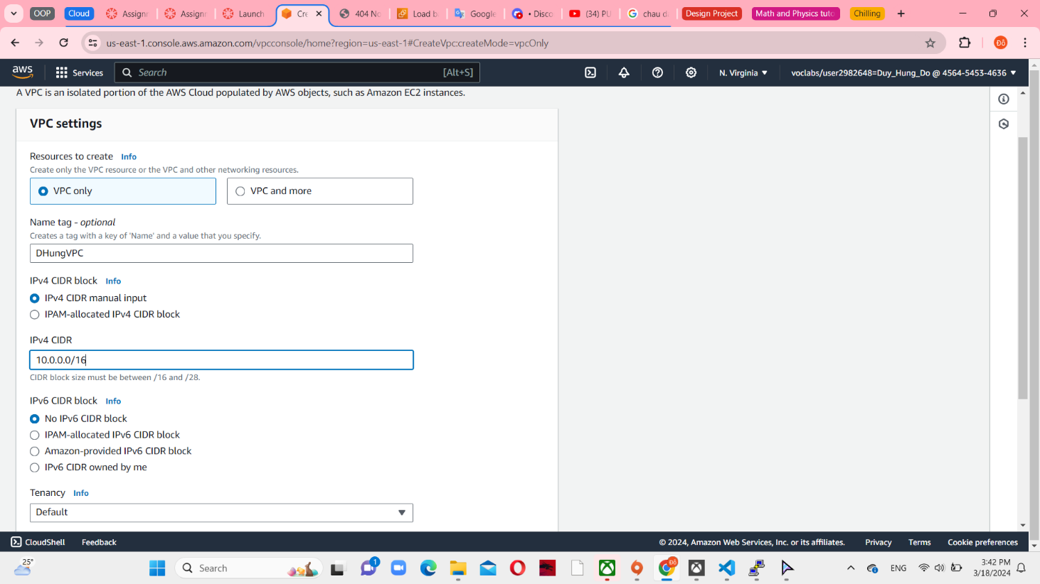

*Figure 1 VPC settings*

In the next step, you have to create 4 subnet provided in 2 availability zones. Public subnet 1 and Private subnet 1 are in zone us-east-1a, with 10.0.1.0/24 and 10.0.3.0/24, respectively. Continuing, Private subnet 1 and private subnet 2 are in zone us-east-1b, with 10.0.2.0/24 and 10.0.4.0/24, in sequence. Set 4 subnets connect with DHungVPC.

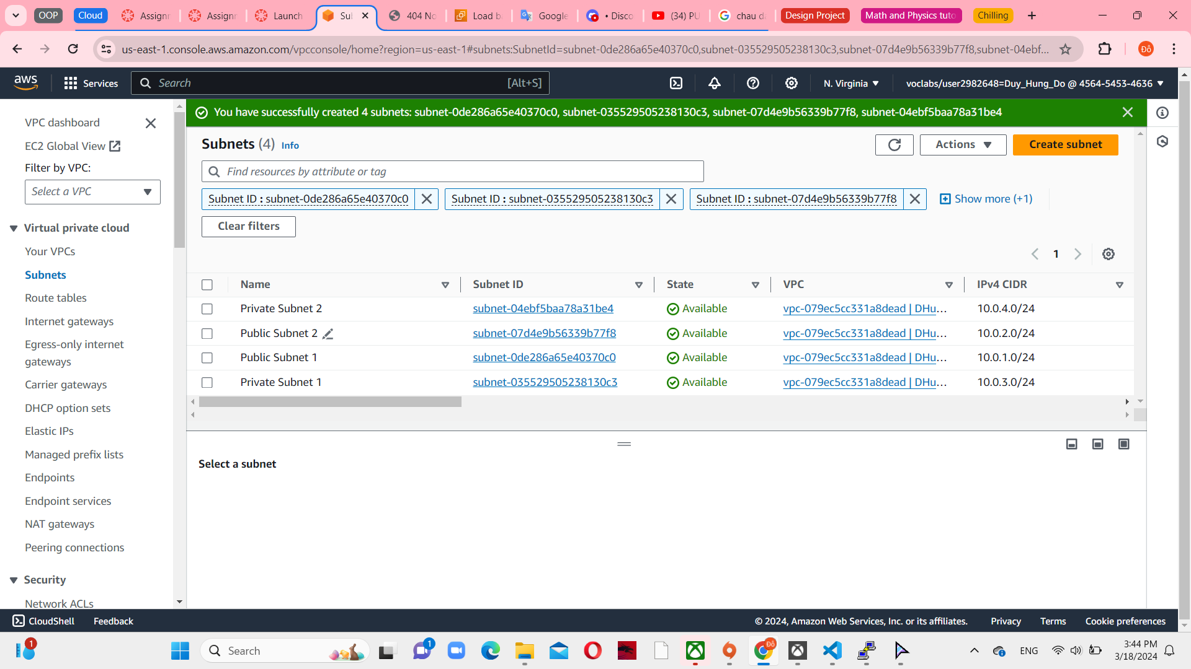

*Figure 2 Set 4 subnets with DHungVPC*

Next, create route tables. There are 2 route tables including public and private. All public and private route tables are attached in 2 availability zones.

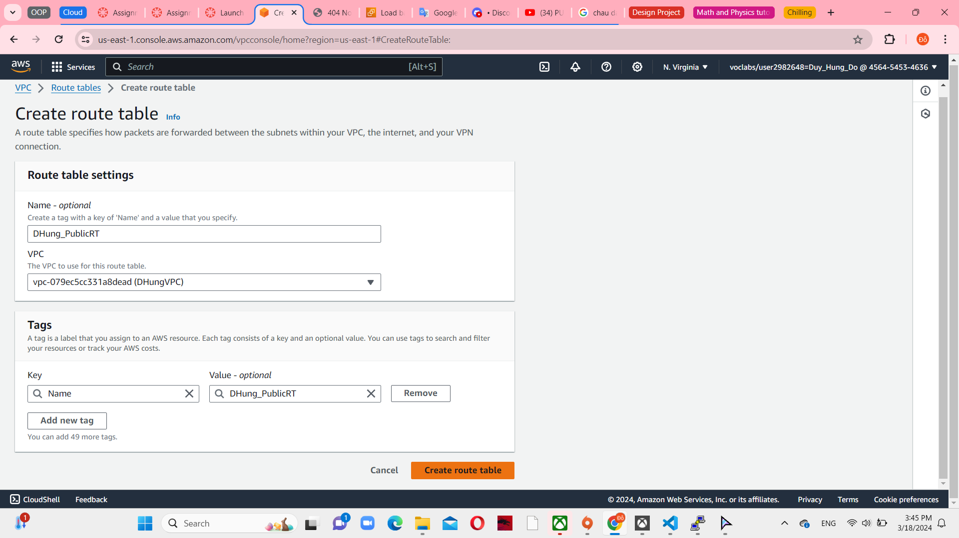

*Figure 3 Public Route table console*

Both 2 route tables are connected to DHungVPC.

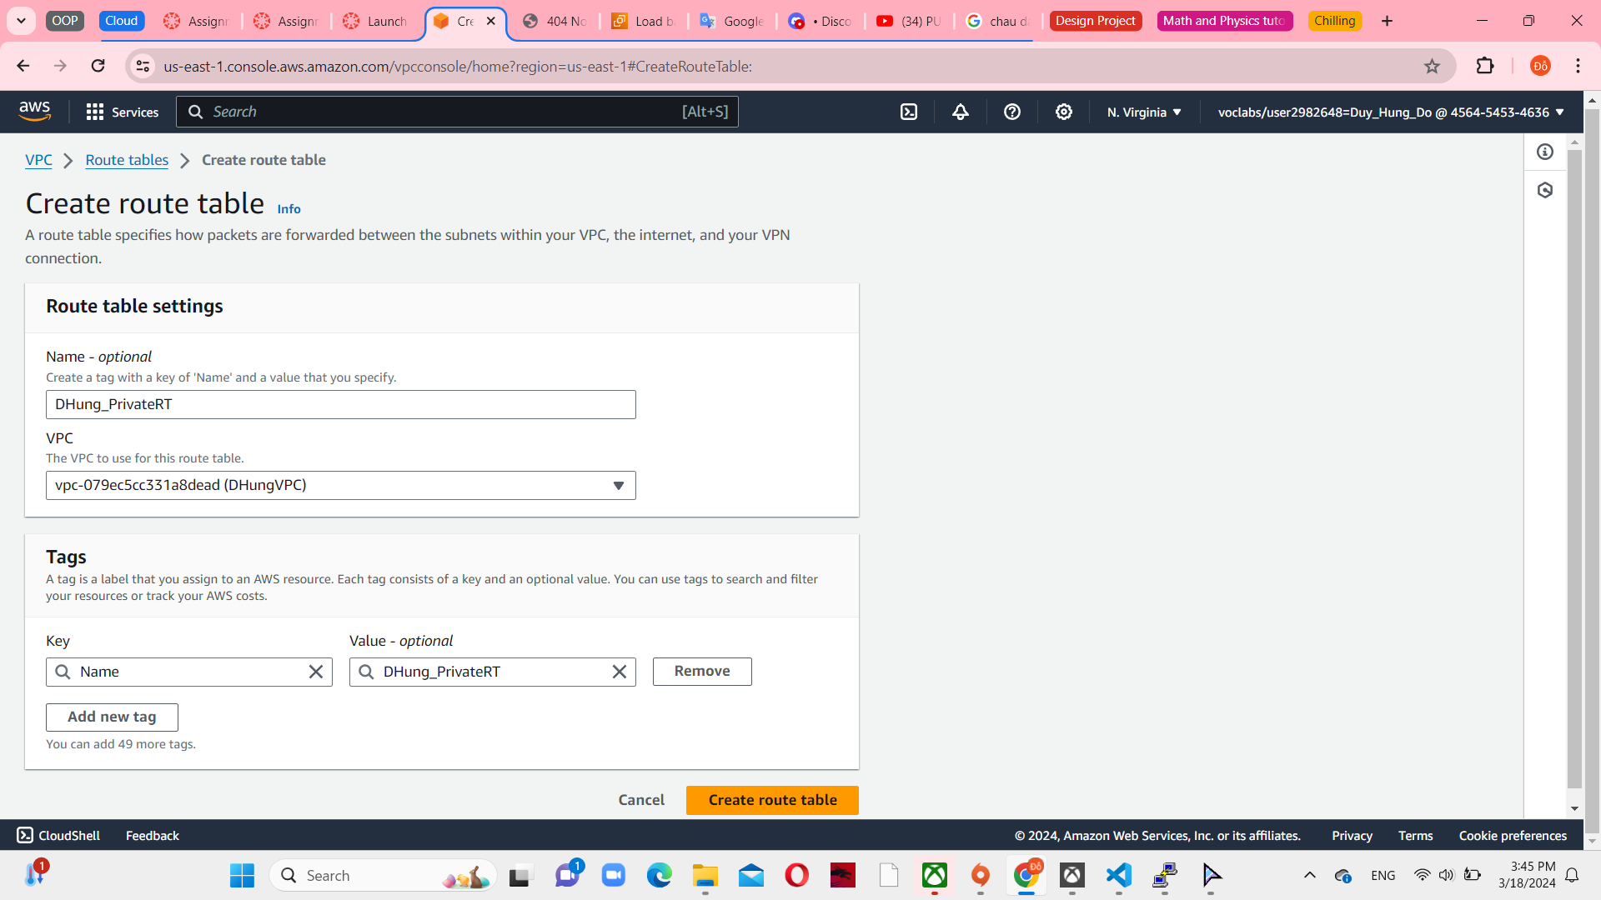

*Figure 4 Private Route table console*

Continue with configuration, set internet gateway for DHungVPC.

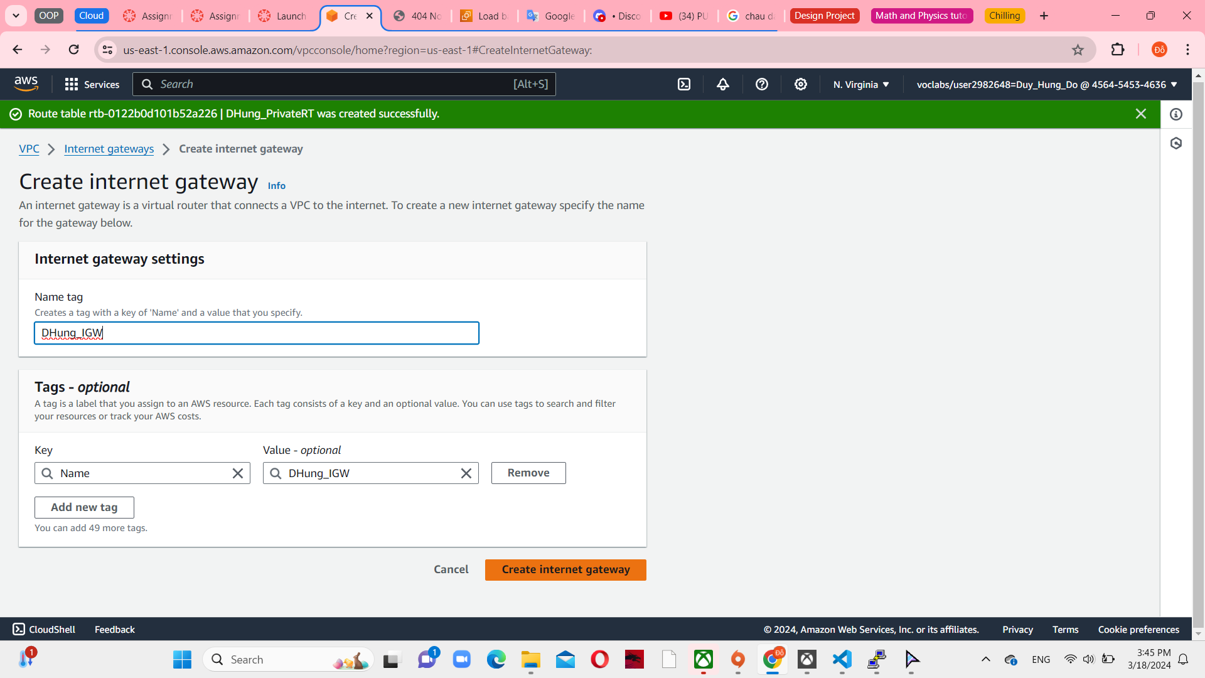

*Figure 5 Create internet gateway*

In this assignment abstract, I choose create NAT gateway instead of NAT security group. It’s provided in Public Subnet 1 and an elastic random IP. But this IP doesn’t use as same as EC2 instance that I’ll create immediately.

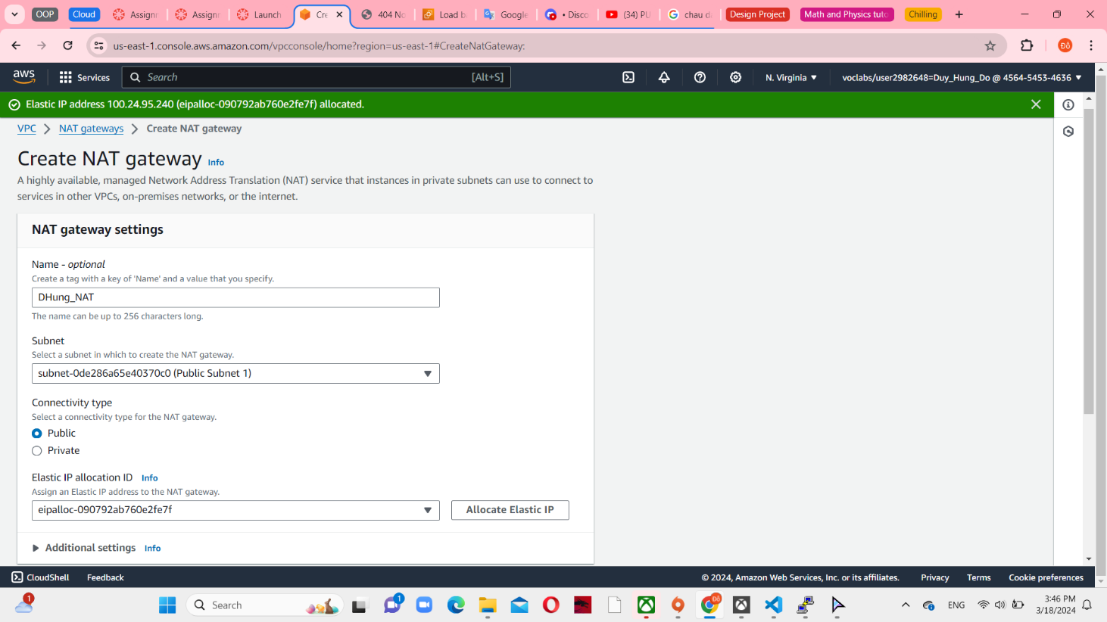

*Figure 6 Create NAT gateway*

At the end of creating VPC step, the public route table is direct traffic to Internet gateway (DHung_IGW), associated with 2 public subnets.

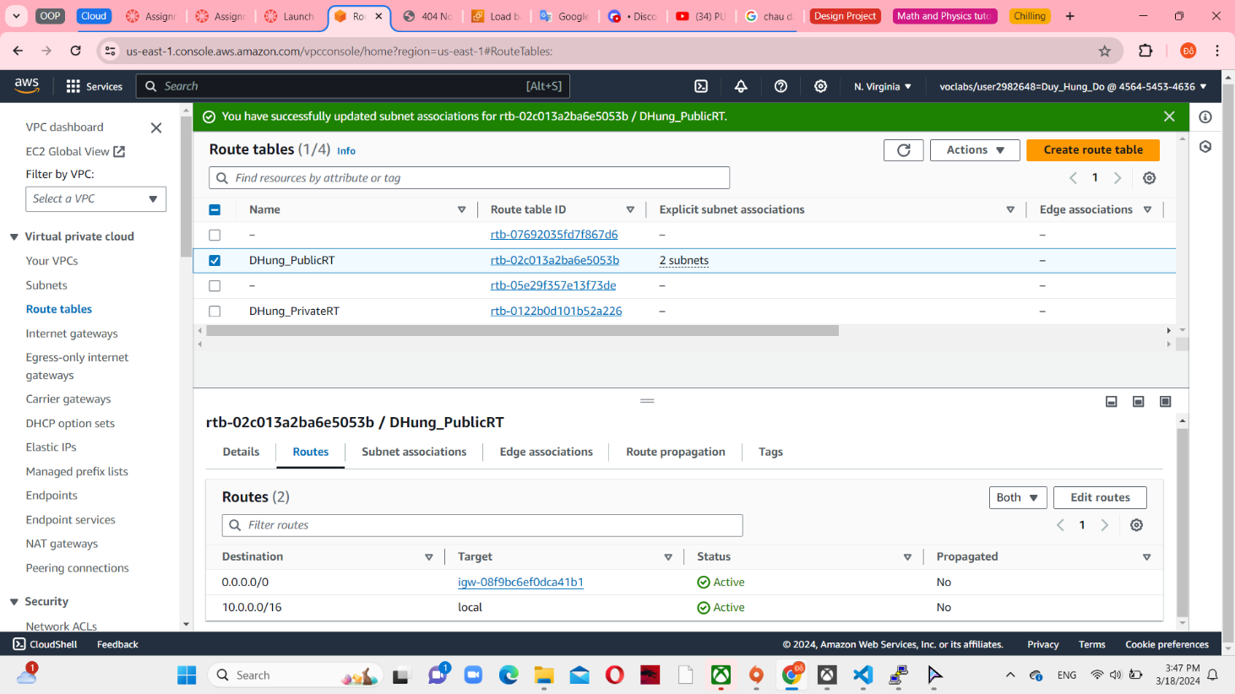

*Figure 7 Config routes and subnet association in Public Route table*

On the other hand, the private subnets are associated with separate route table that routes traffic to NAT gateway.

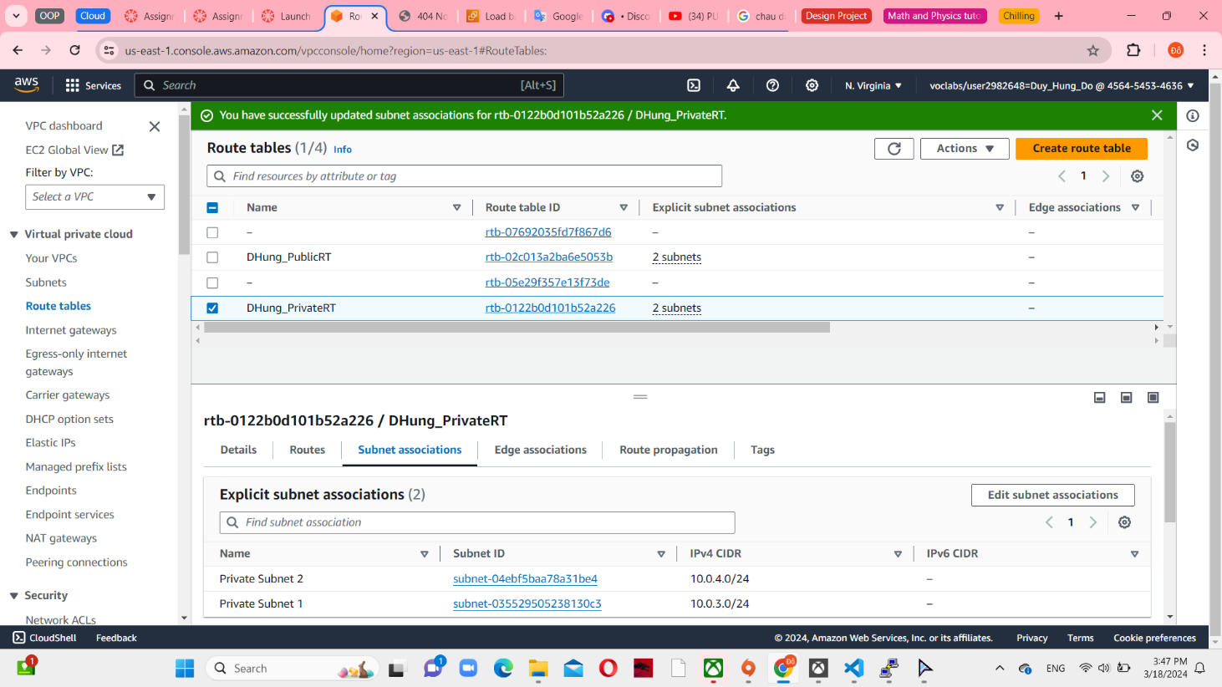

*Figure 8 Config routes and subnet association in Private Route table*

**Task 2: Create Security group**

In assignment 2 requirements, there are 4 security groups that have to created (minus NAT Security group as I mentioned). Firstly, I set ELBSG (Security group allow for Load Balancer). Set inbound rules, type are HTTP and HTTPS, all Anywhere-IPv4 source. Obviously, it has to connect with DHungVPC.

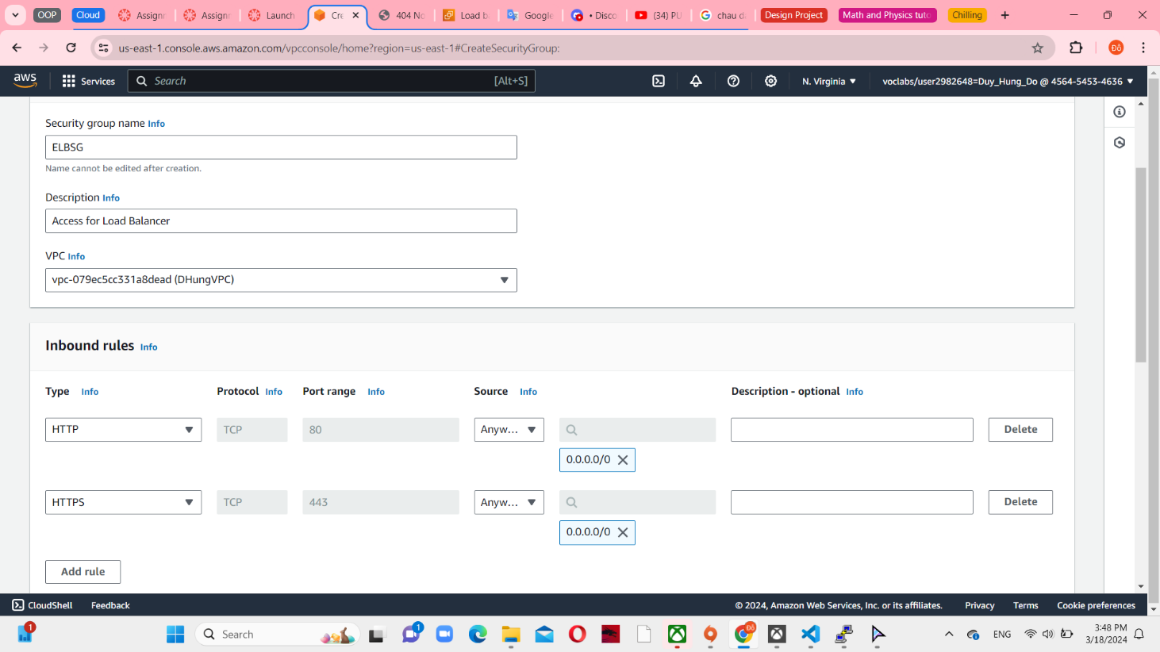

*Figure 9 ELBSG configuration*

DevServerSG is access for Dev Server so you can require all traffic to this security group. Of course, Anywhere-IPv4 is the source of this inbound rules.

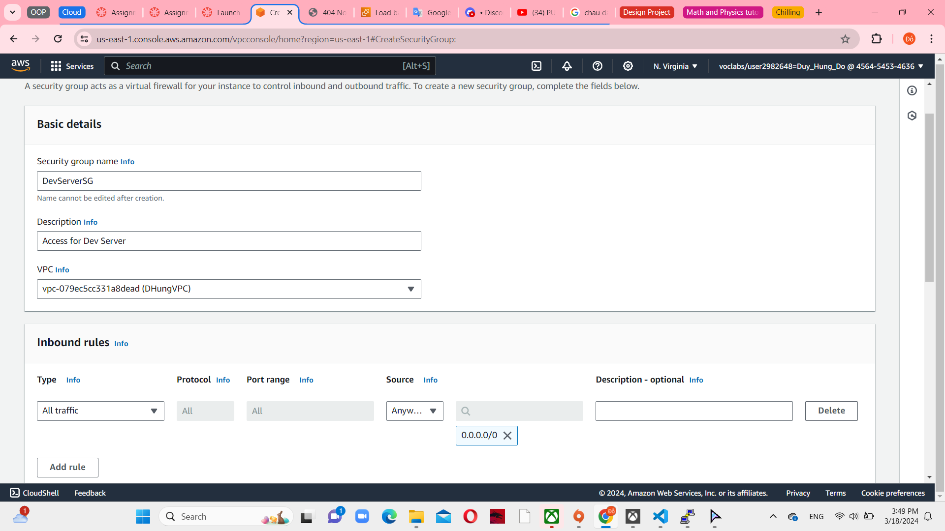

*Figure 10 DevServerSG configuration*

WebServerSG is access for Web Server – in Launch template that I used for Auto Scaling group after. Set HTTP and HTTPS for inbound rules with source from ELBSG.

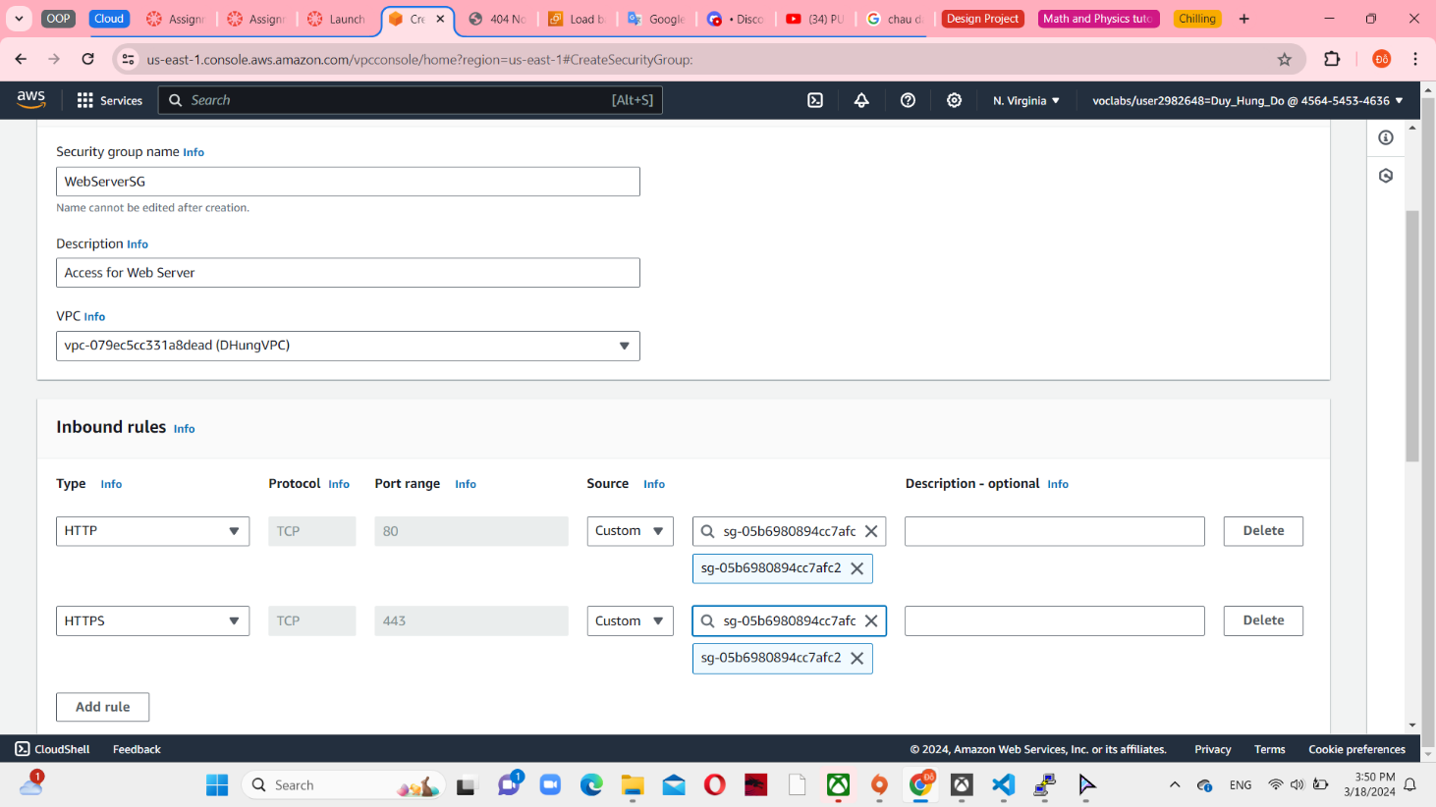

*Figure 11 WebServerSG configuration*

DBServerSG is access for RDS database. There are 2 MySQL/Aurora inbound rules have created, one is allow with DevServerSG, other is WebServerSG. And all outbound rules in 4 security groups set default – all traffic.

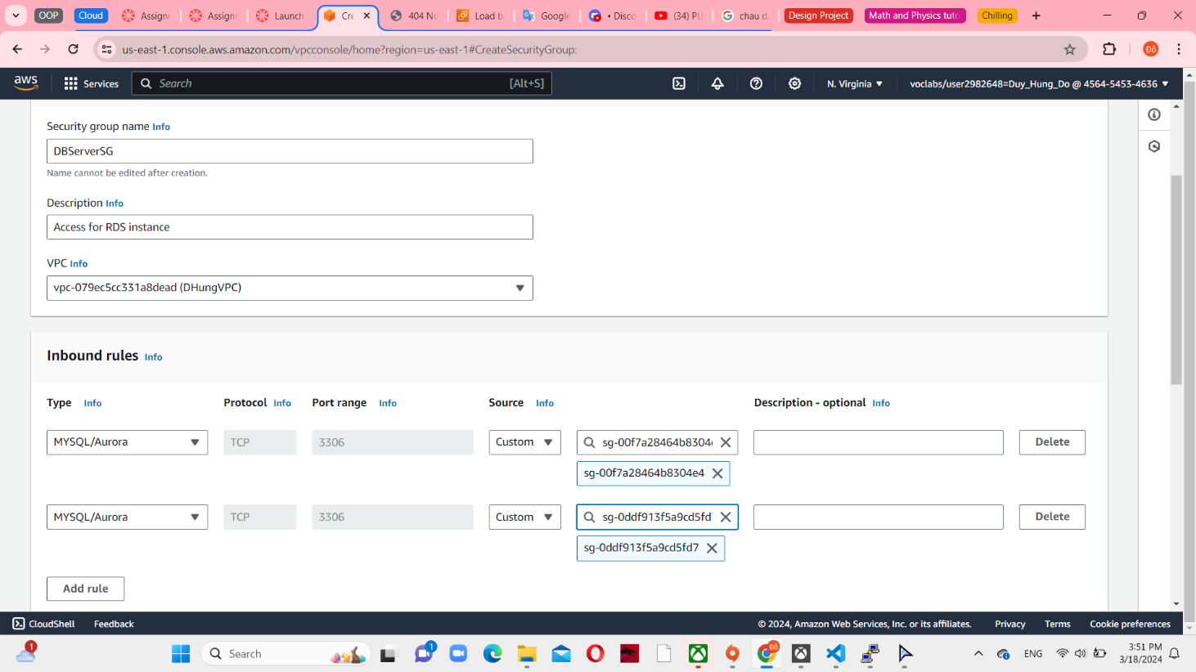

*Figure 12 DBServerSG configuration*

**Task 3: Create EC2 instance.**

Dev Server is configured with t2-micro and HVM Amazon Linux 2. I create my own key pair and SSD volume type. Select existing security group in DHungVPC and it is connected to DevServerSG. IAM role is LabRole and connect with Cloudwatch monitoring. And then, set a new elastic IP address, it is different with NAT gateways and associated with EC2 instance. Notice that Dev server is not receiving traffic from ELB.

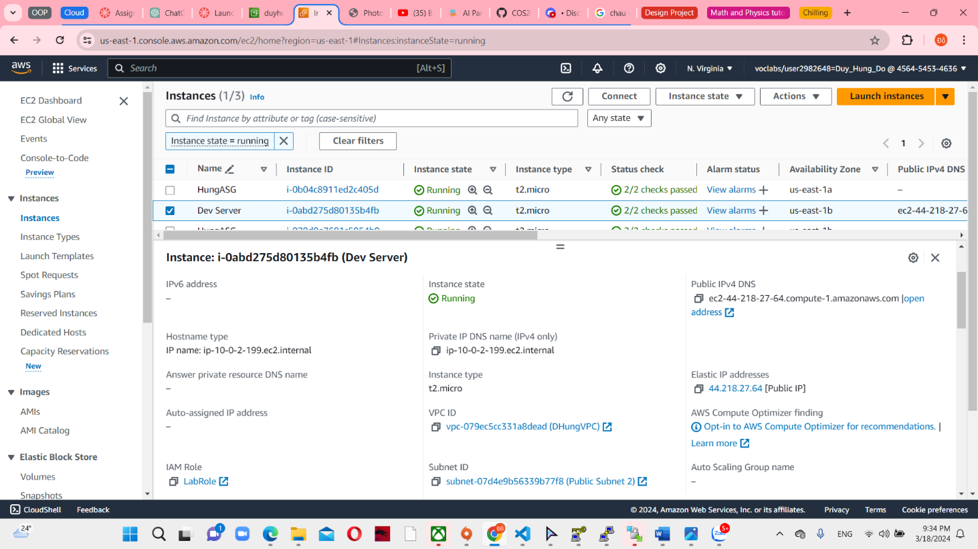

*Figure 13 Dev Server instance*

And then, you can access to Putty to activate the IPv4 CIDR. Set IPv4 as the hostname and add file ppk from agent. Install phpMyAdmin through this address and open it in a new web browser. Furthermore, install zip file that contains AWS SDK PHP. You can use elb dns to upload album instead of dns in ec2. This action I have done and follow in assignment 1b.

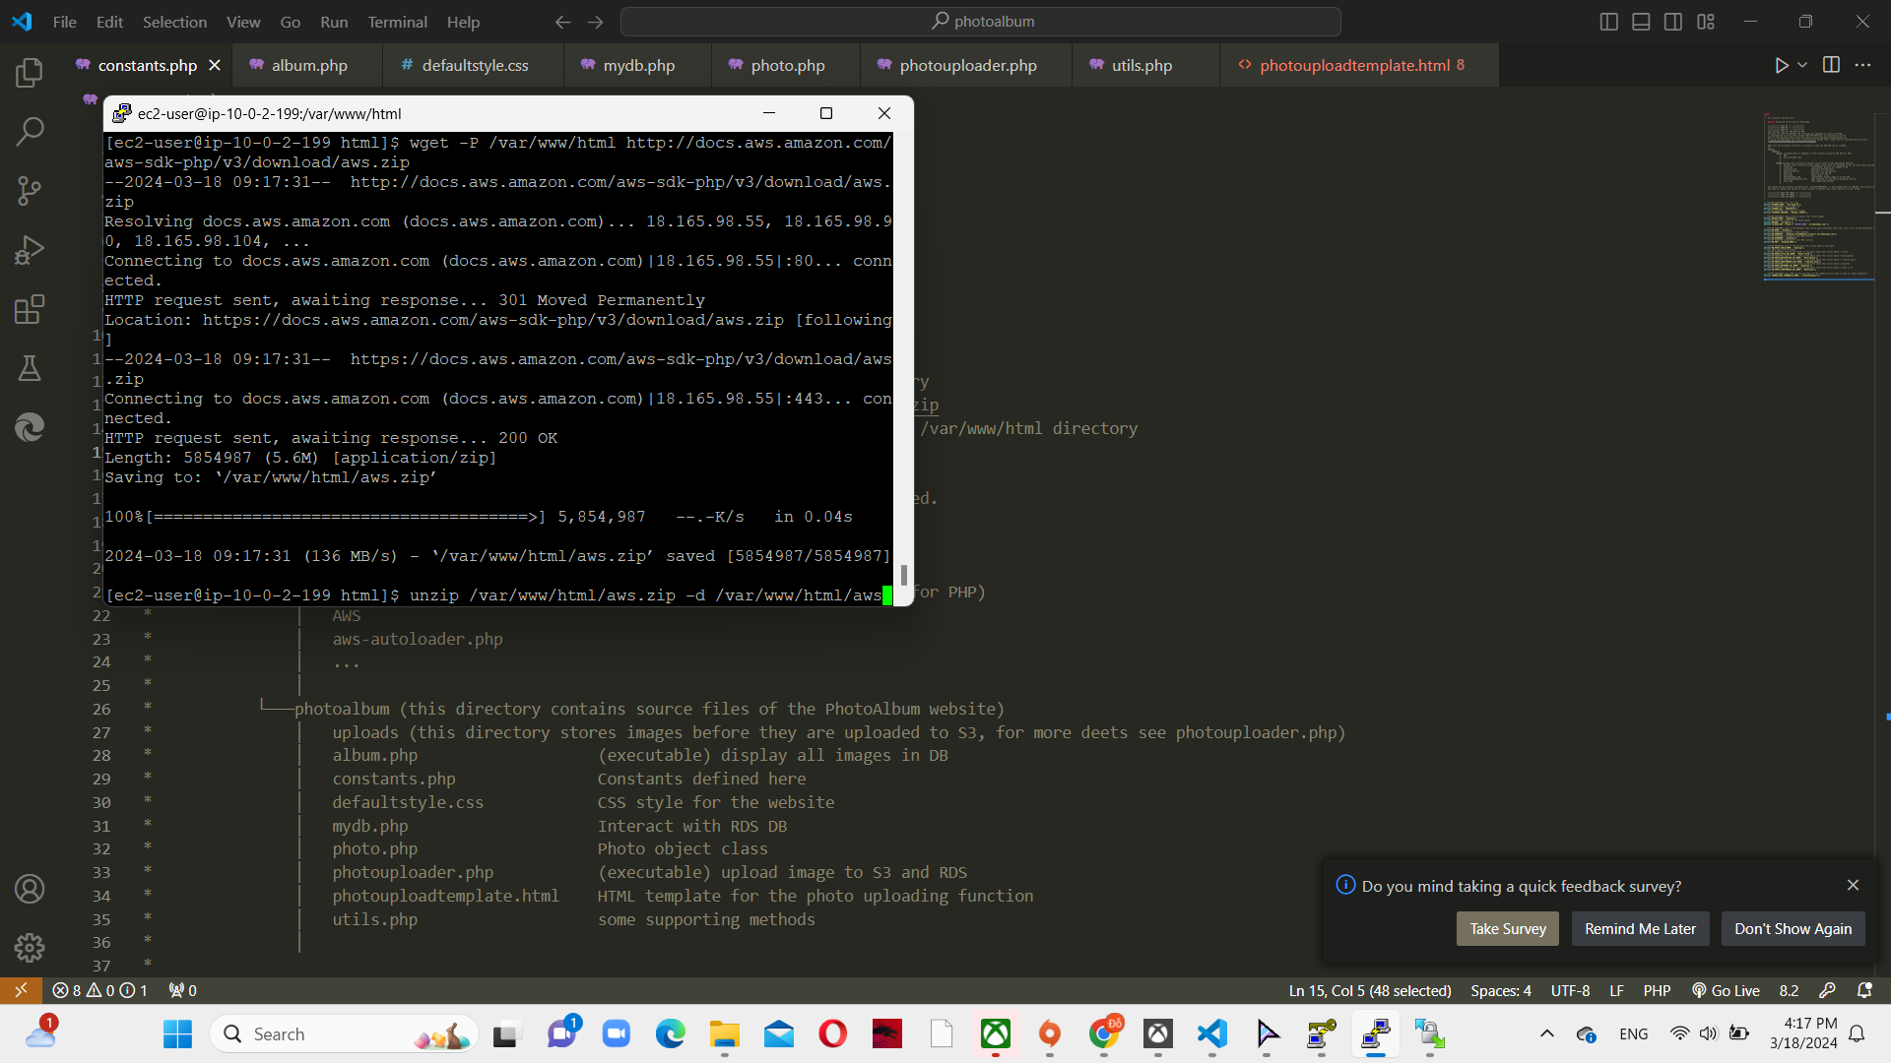

*Figure 14 Install phpMyAdmin and AWS SDK*

**Task 4: RDS instance**

After install phpMyAdmin, I have created a RDS instance – database. Engine options is MySQL and 8.0.34 version with Free tier template.

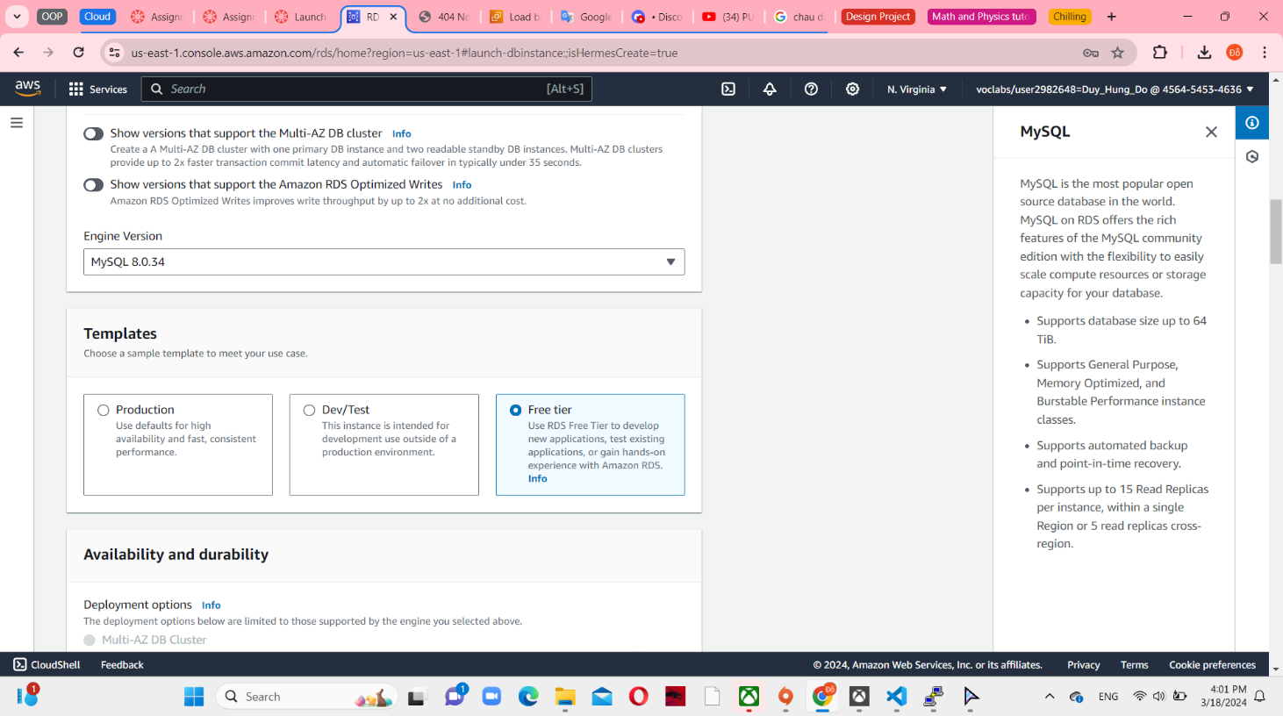

*Figure 15 Engine options and templates in RDS database*

You have to create subnet groups in rds. It connect with DHungVPC with 2 private subnets in 2 availability zones.

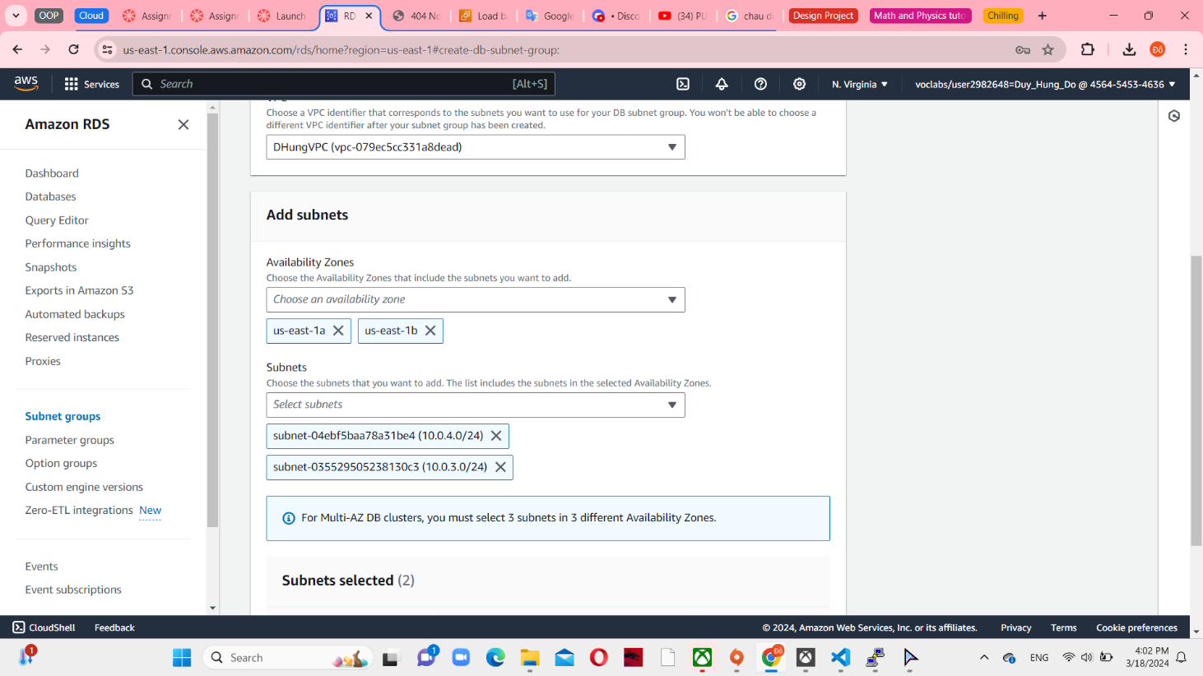

*Figure 16 RDS subnet groups*

Use DBServerSG for VPC security group and AZ set to us-east-1a following a diagram in abstract. Use DHungVPC and choose 1a and 1b as a availability zones with 2 private subnets. (assignment 2 db subnet group). The RDS instance is connected to a subnet group called db subnetgroup, which comprises private subnets in both Availability Zones.

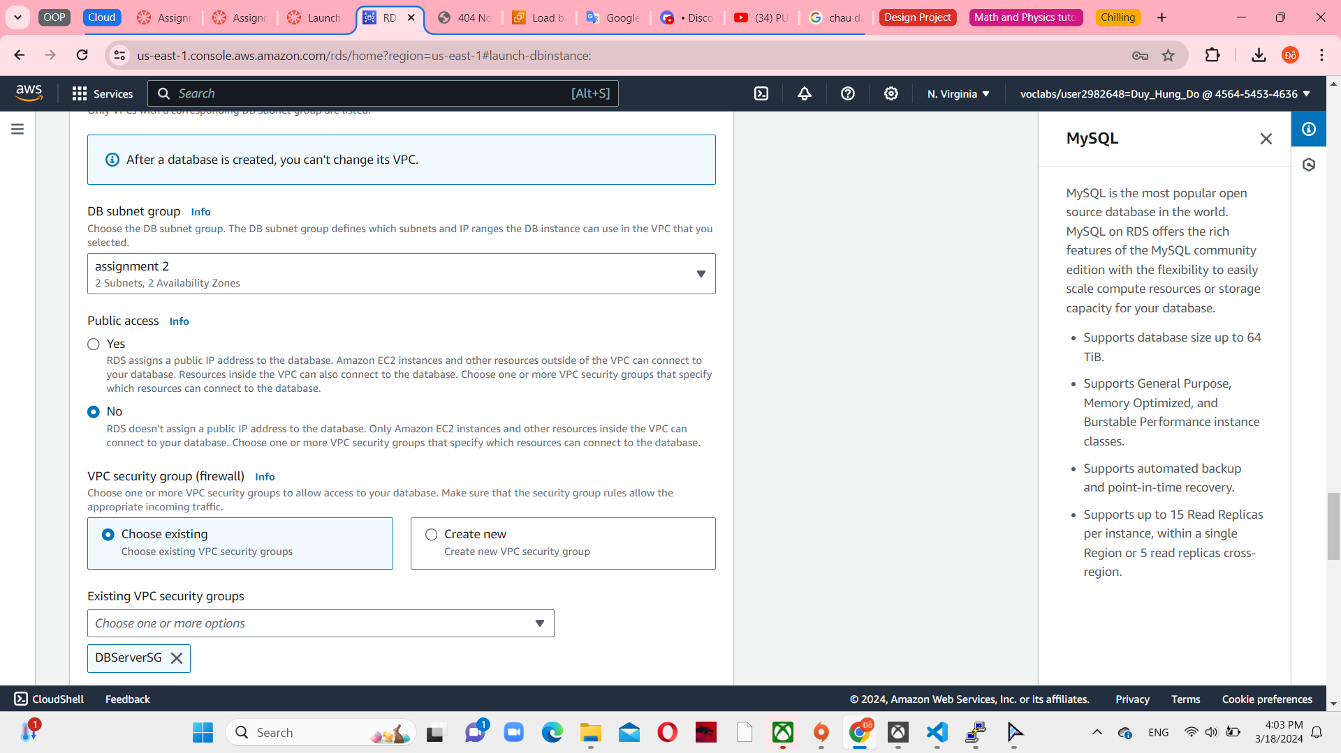

*Figure 17 RDS connect with DHungVPC and 2 private subnets*

**Task 5: Create S3 bucket**

S3 is connect directly with RDS instance. S3 is provided in upload file such as images, pdf, word… Set a name and unblock all public access. Because I like football so I upload 2 logo football club’ images.

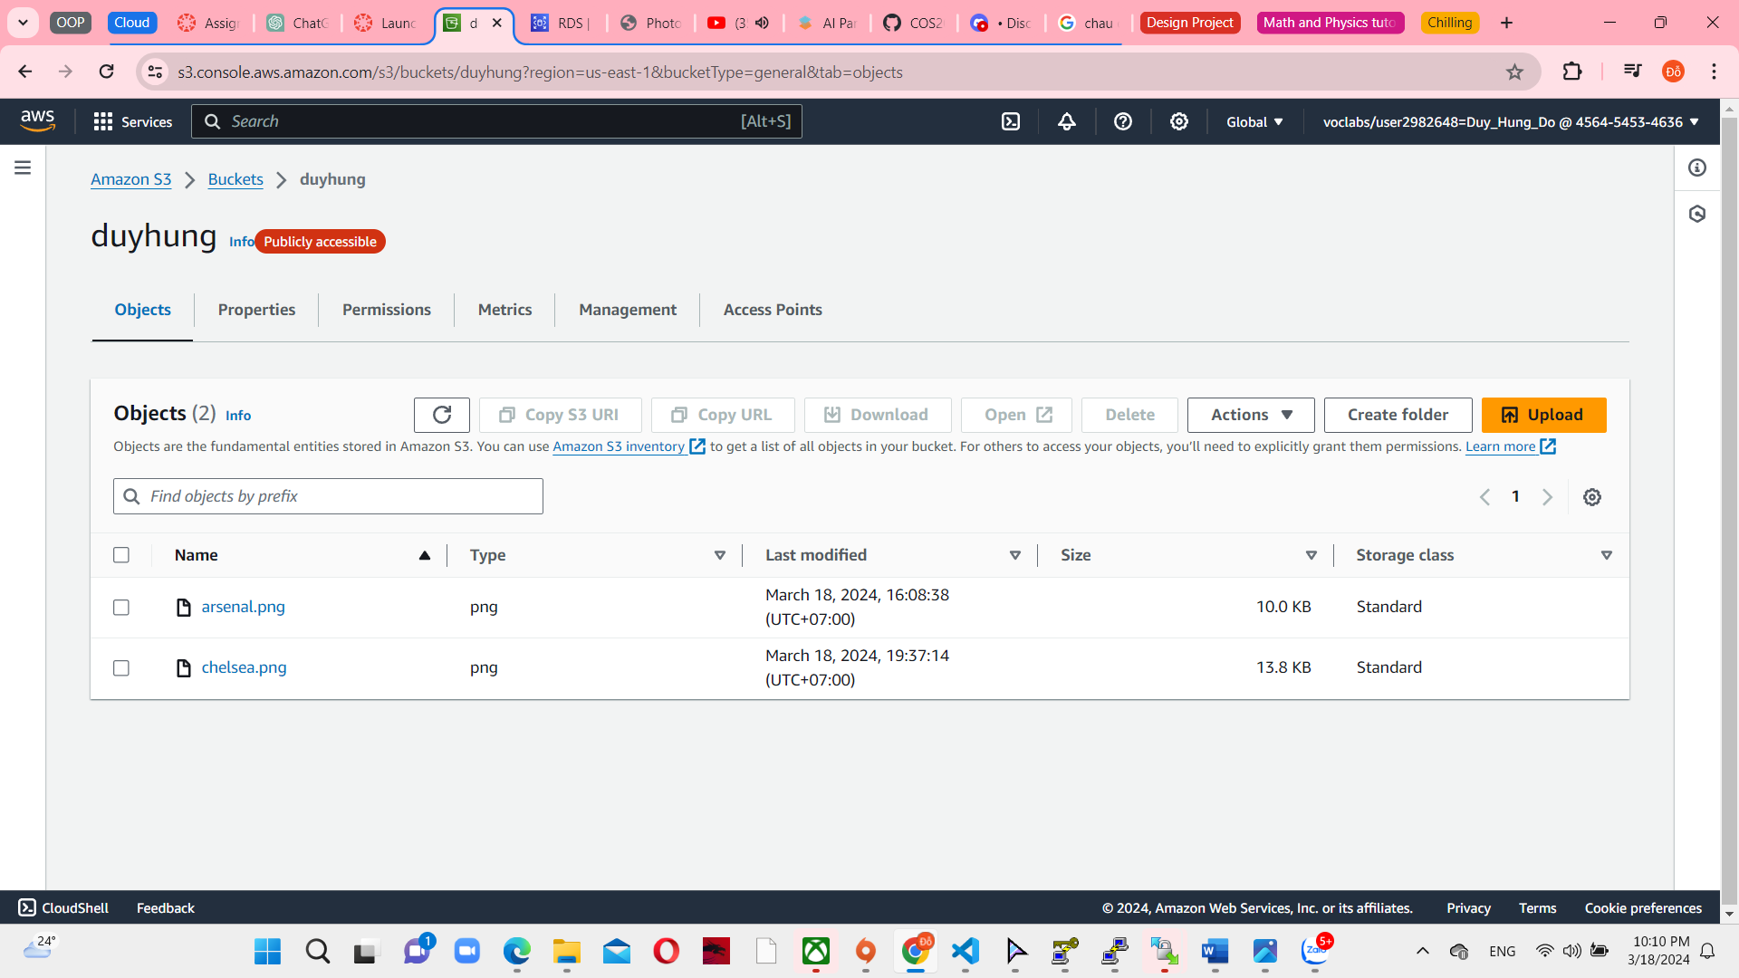

*Figure 18 duyhung S3 bucket with 2 photos*

Because you have to upload website through elb dns so the bucket policy is different from assignment 1b. you have to add more id and link load balancer that access website. This policy ensures that only GET requests originating from the specified domains have access to the S3 bucket. It guarantees a secure and controlled access policy for the objects in the bucket.

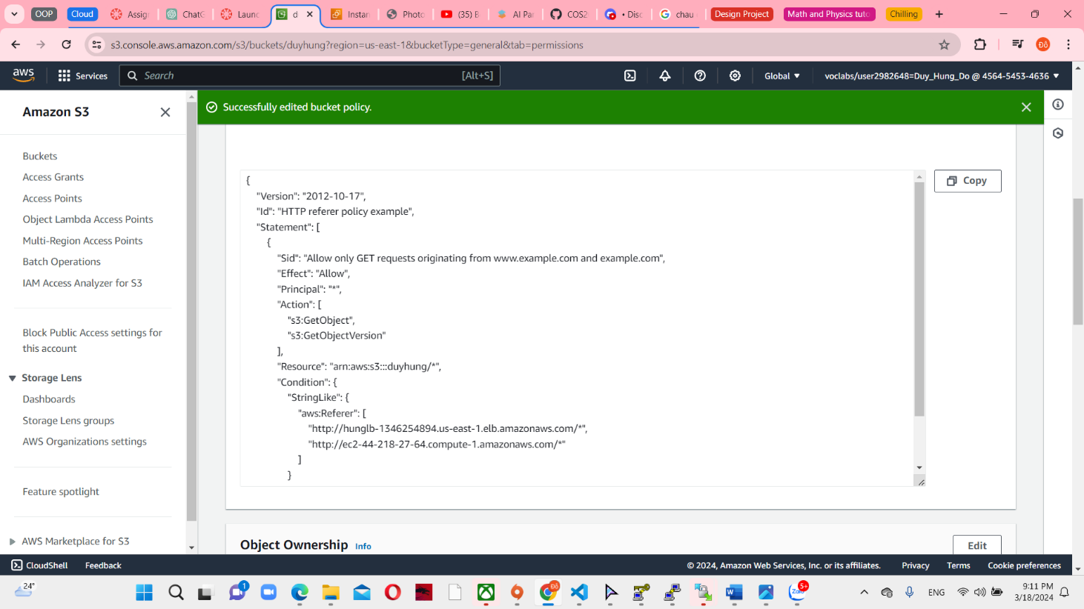

*Figure 19 S3 bucket policy update*

**Task 6: Create Load balencer**

Create AMI from Dev Server instance. Set the name of the Web Server AMI to help you recognize the SG easier.

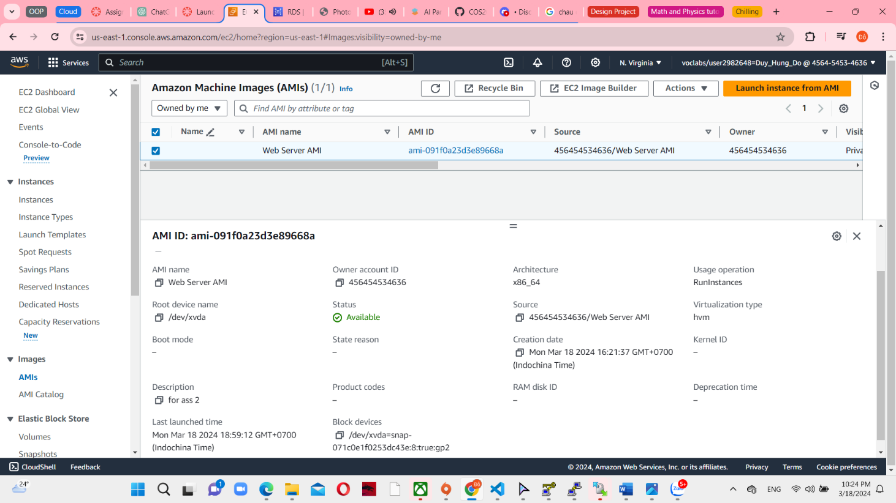

*Figure 20 Amazon Machine images config*

After that, create a new target group with IPv4 address type and DHungVPC.

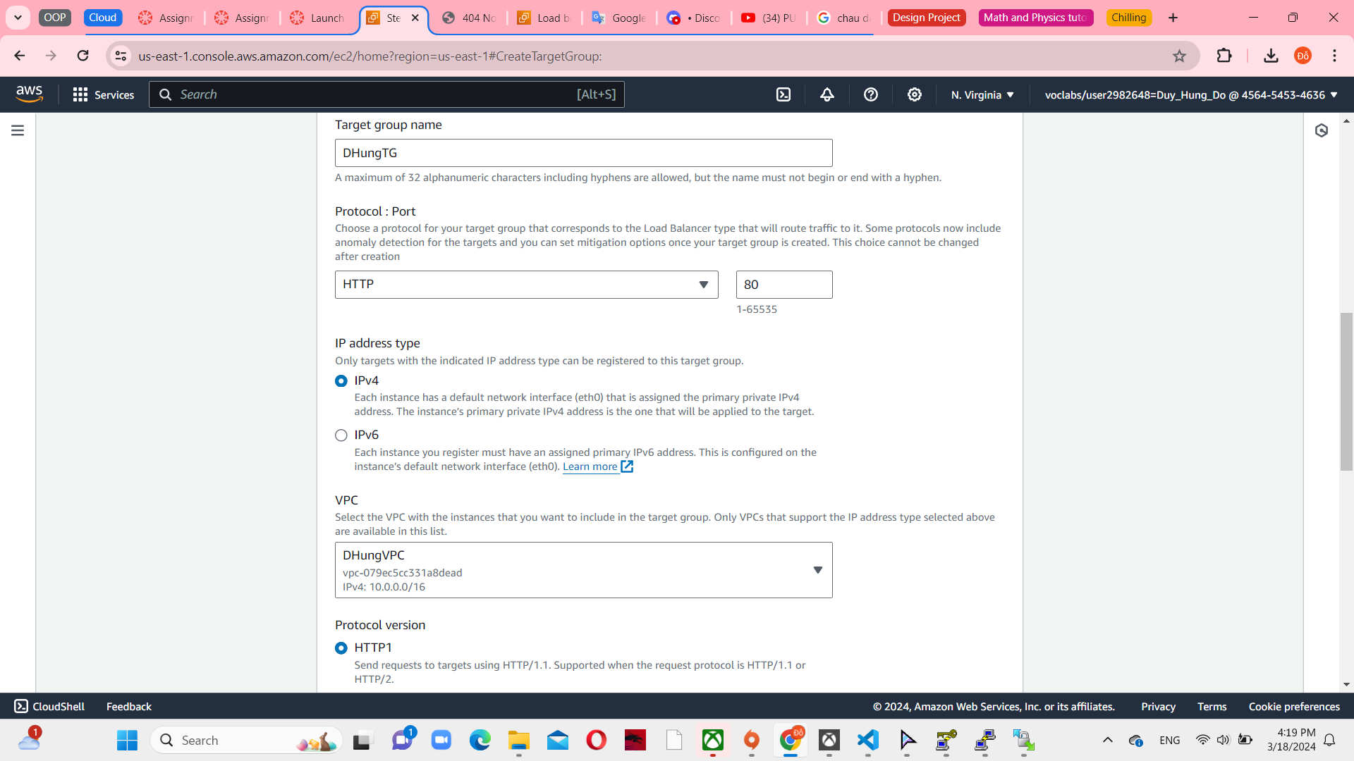

*Figure 21 Target group console*

Create Application Load balancer, set the Network mapping as DHungVPC, 2 public subnet for each availability zones.

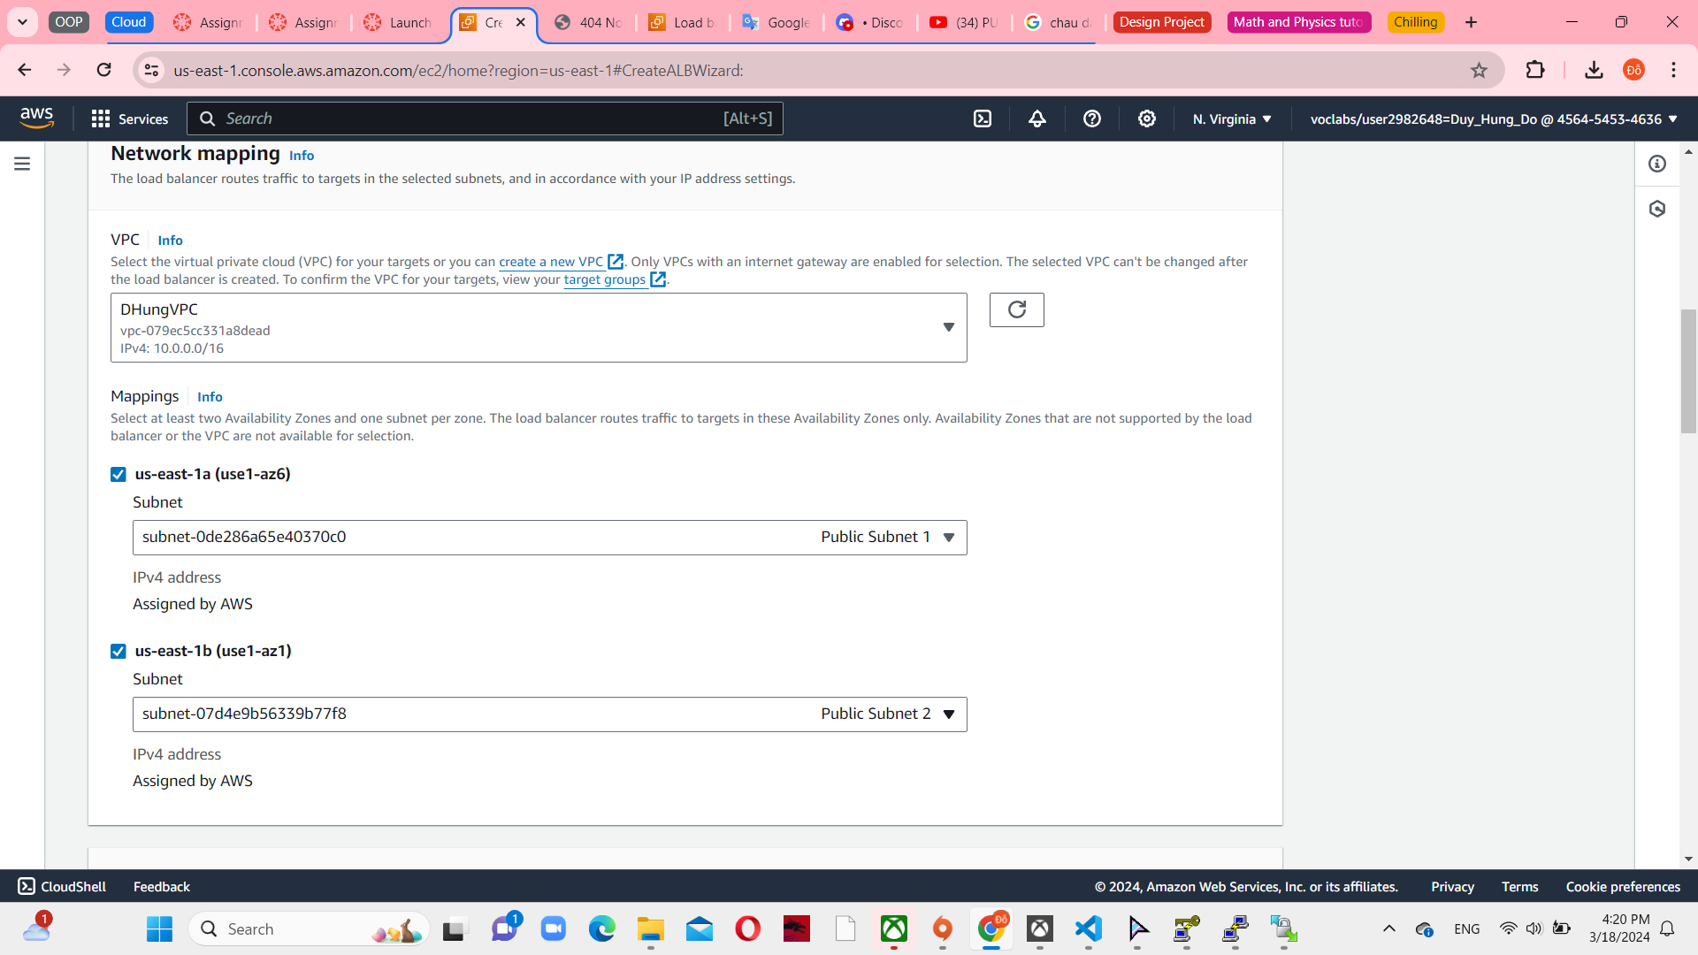

*Figure 22 Network mapping in Load balencer*

Select ELBSG as a security group and DHungTg default action as a target group with HTTP protocol. It is mapped with HTTP inbound rule in DBServer Security group.

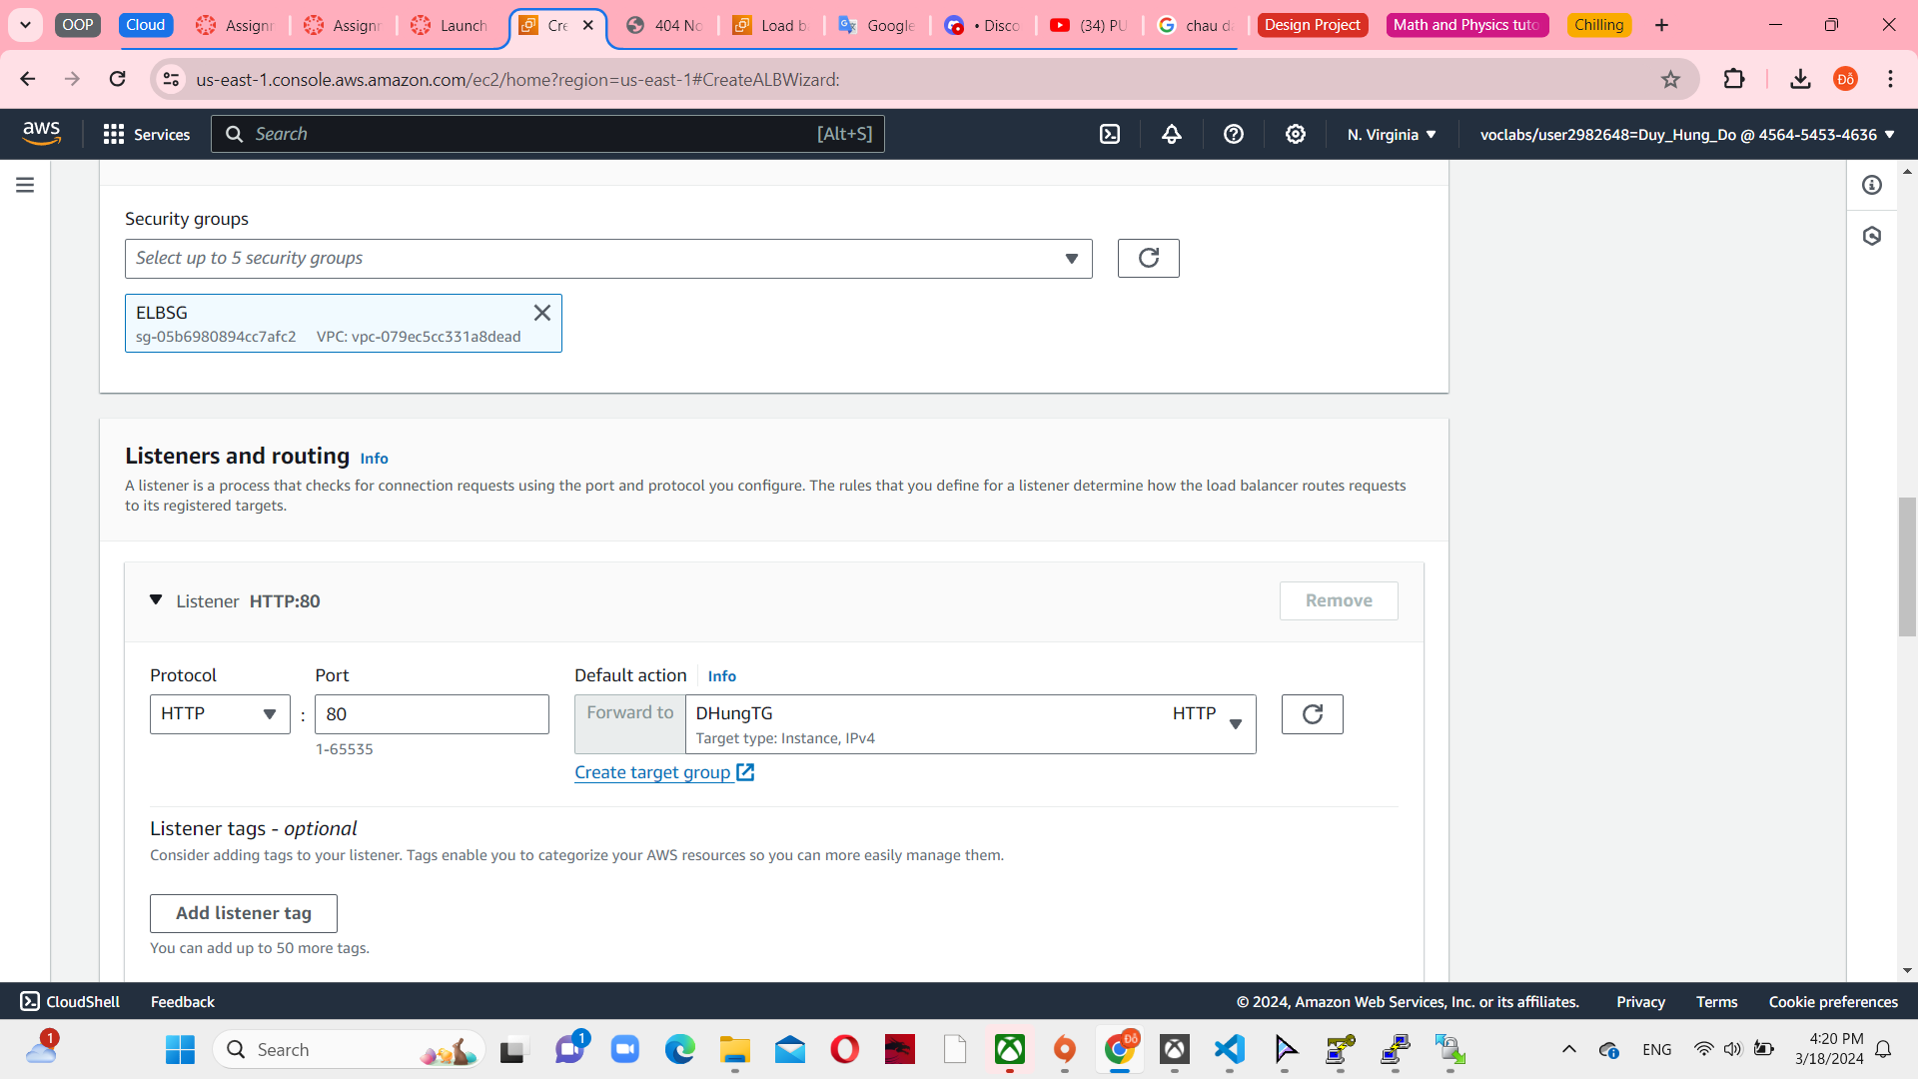

*Figure 23 Listeners and routing in Load balancer*

**Task 7: Create Auto Scaling group through Launch template**

Firstly, create Launch template. Use Web Server AMI that I have created before.

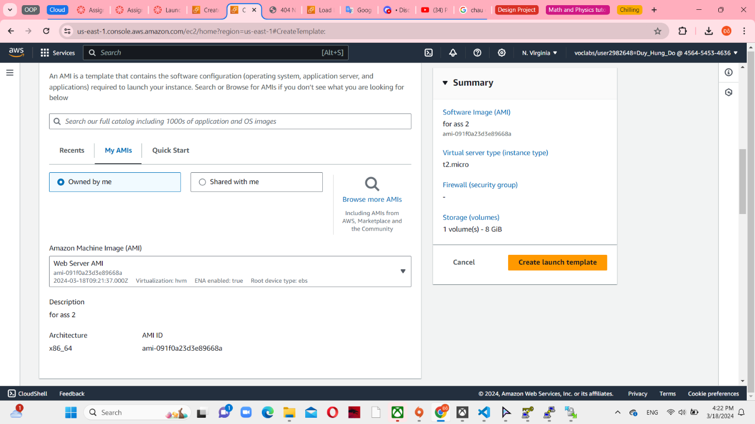

*Figure 24 AMI in launch template*

Instance type t2.micro and the same key pair with EC2 instance. Select existing security group and choose WebServerSG. IAM role LabInstanceProfile attached and enable CloudWatch monitoring.

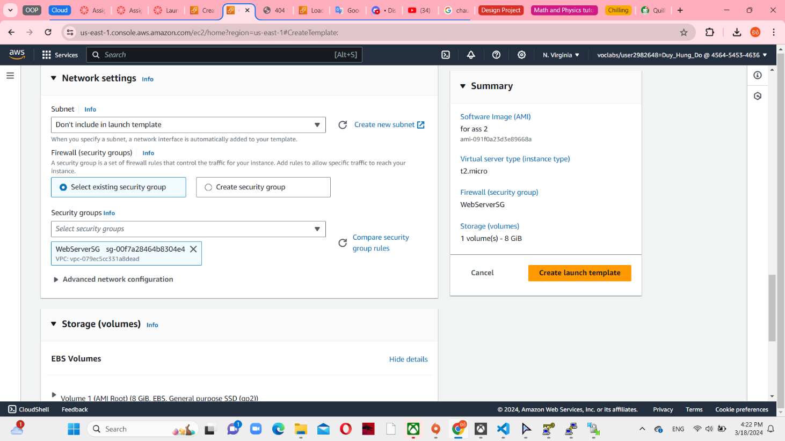

*Figure 25 Network settings in launch template*

In Auto Scaling group, use HungLT – my launch template – has created before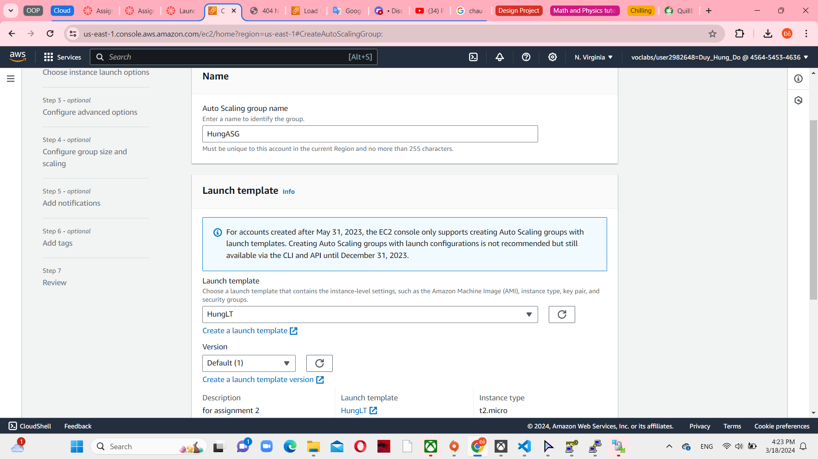

*Figure 26 ASG name and connect with Launch template*

The ASG is specifically configured to launch instances into 2 private subnets through DHungVPC

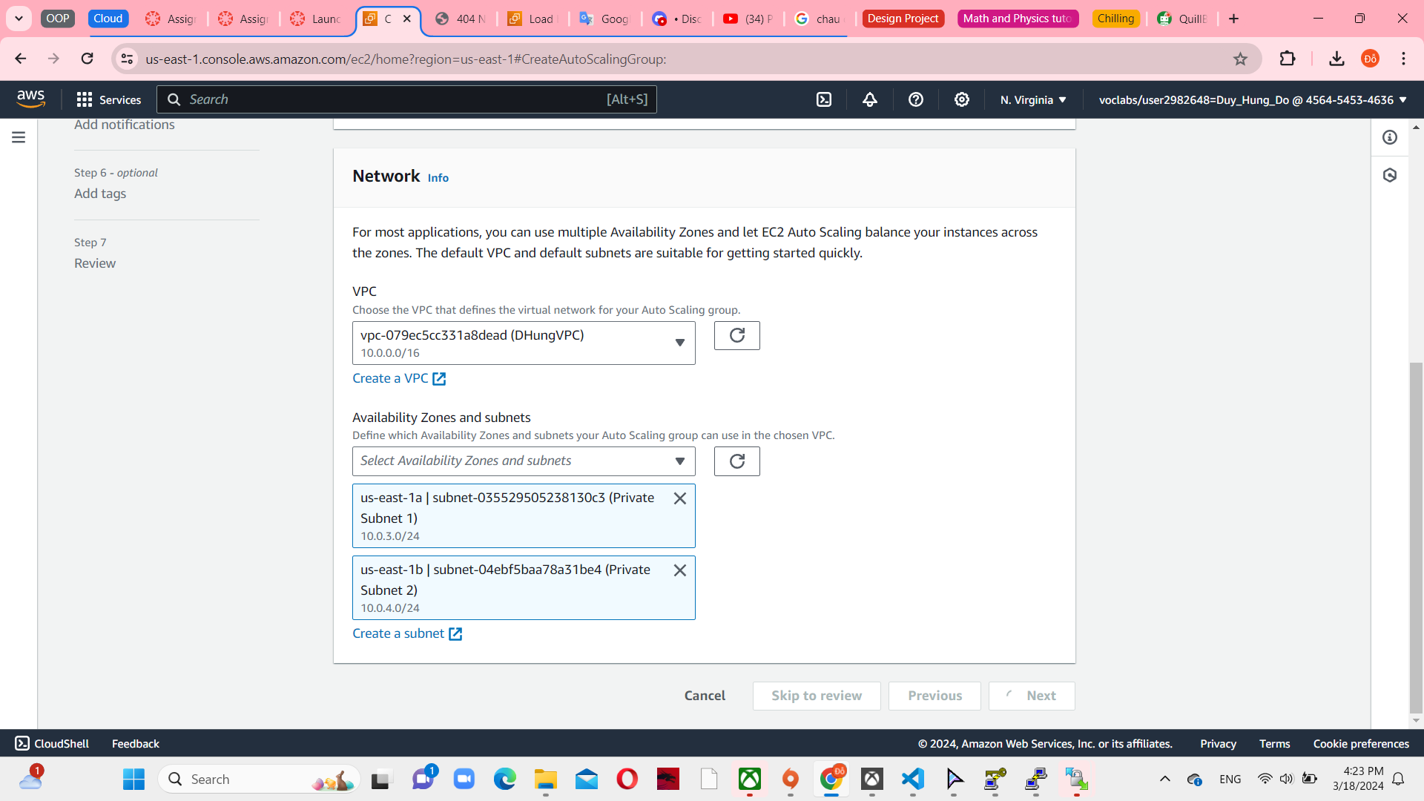

*Figure 27 Network in ASG*

Choose load balancer you have created before in the next step.

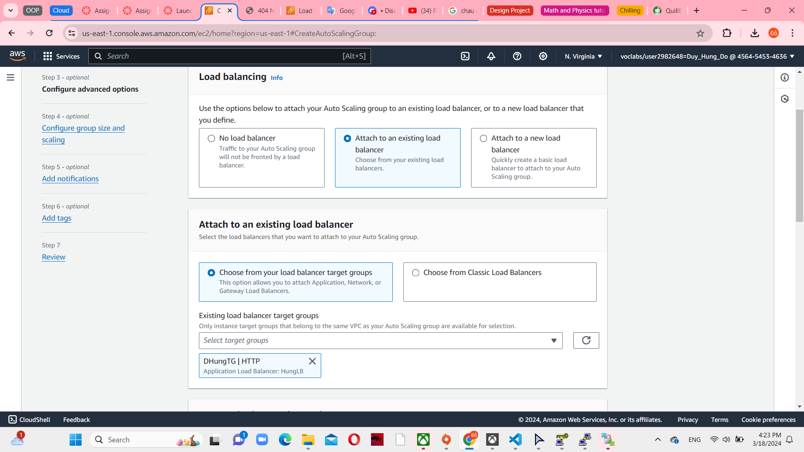

*Figure 28 Attach to an exiting load balancer*

Use target tracking scaling policy and apply load balancer request per target to get a healthy target. Change target value from 50 to 30 as a requirement.

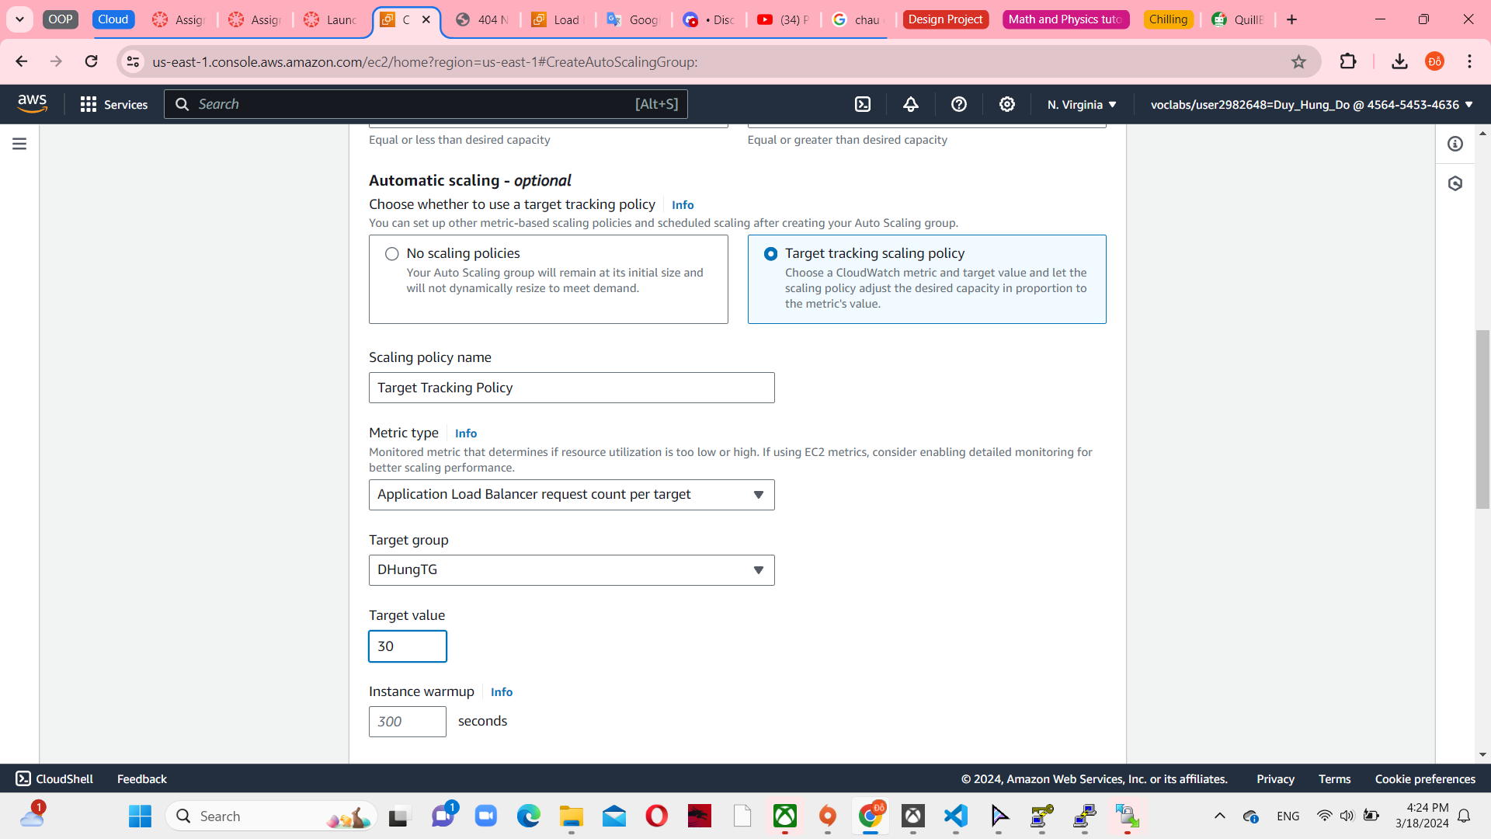

*Figure 29 Automatic Scaling in ASG*

Maintaining at least 2 instances and no more than 3 instances, with 2 instances being the preferred amount, guarantees that the application always has a sufficient number of instances while also limiting the infrastructure's scaling to the specified maximum.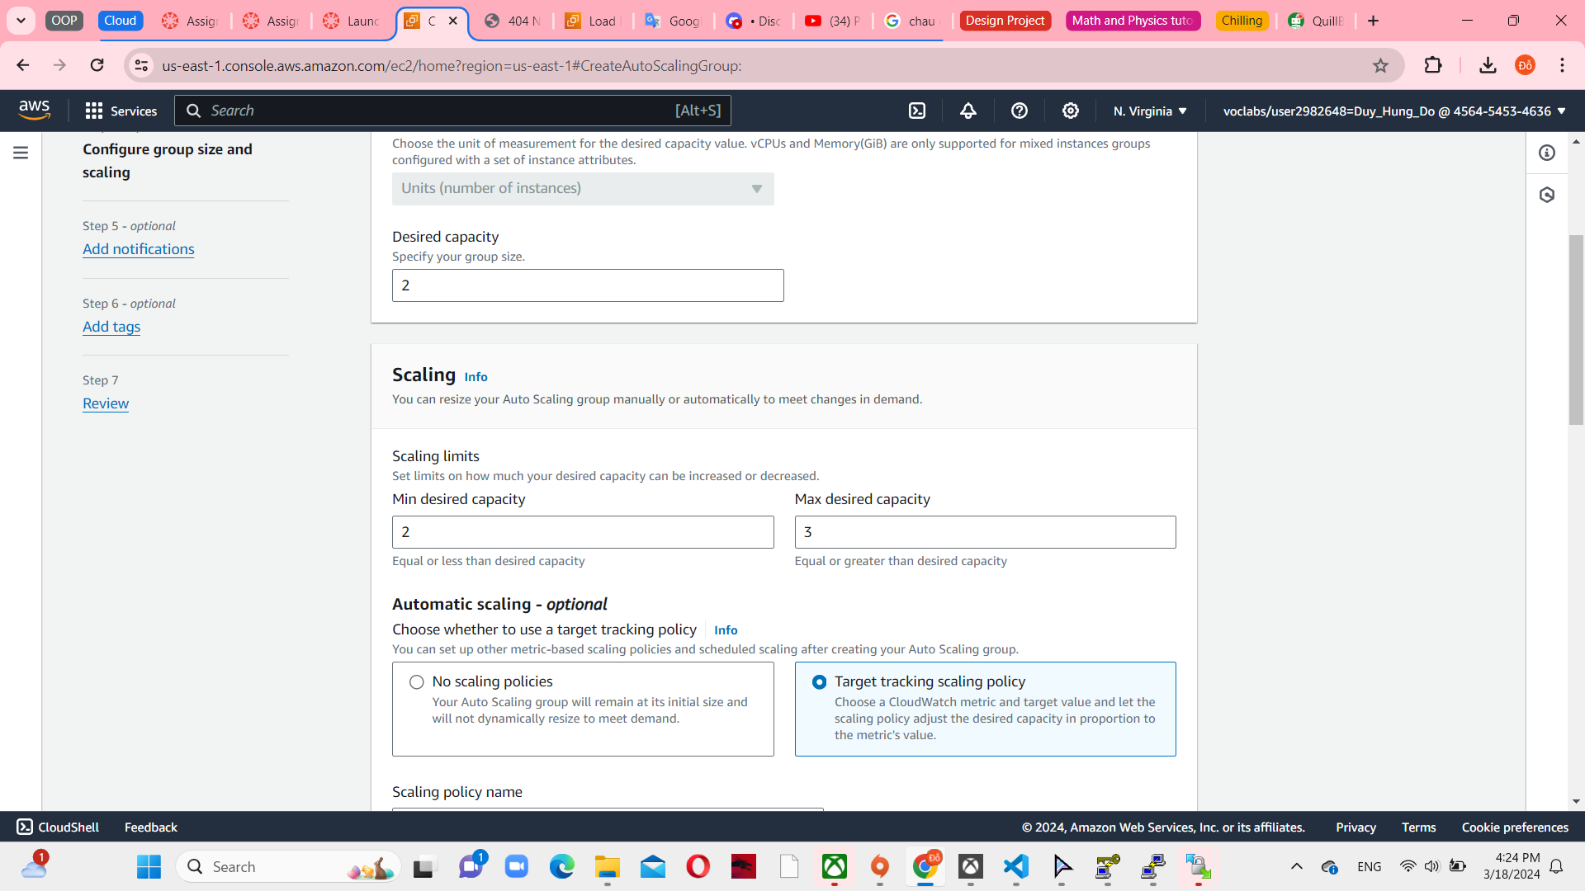

*Figure 30 Scaling in ASG*

Review it and I can see 2 more HungASG in EC2 instance running. After 2/2 check passed status in HungASG, the healthy status is appear in register targets. It means that I can use ELB dns for open a new website.

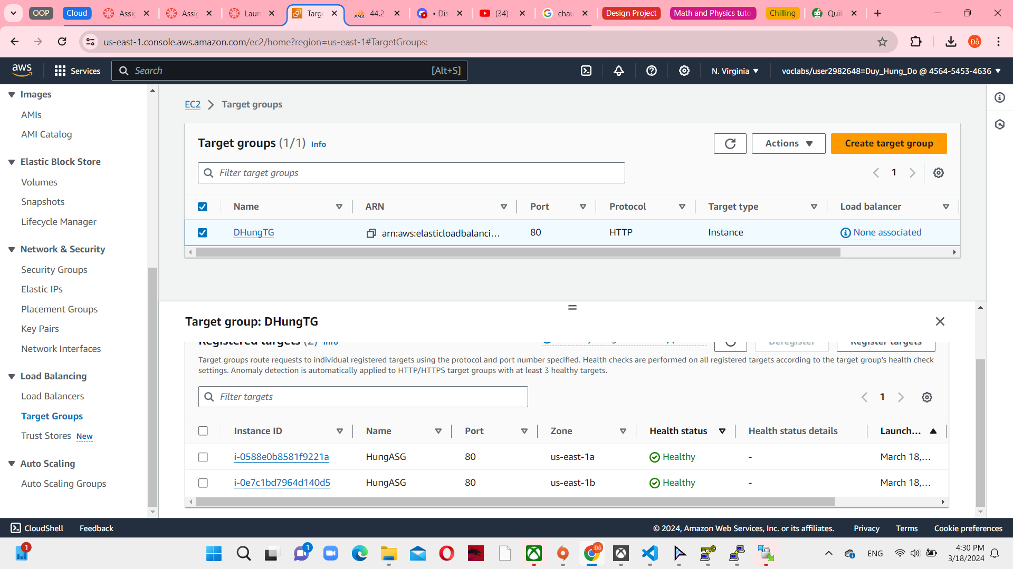

*Figure 31 Healthy target group*

After that, use Public Ipv4 DNS to open php myadmin. Config database similar to assignment 1b like this image below.

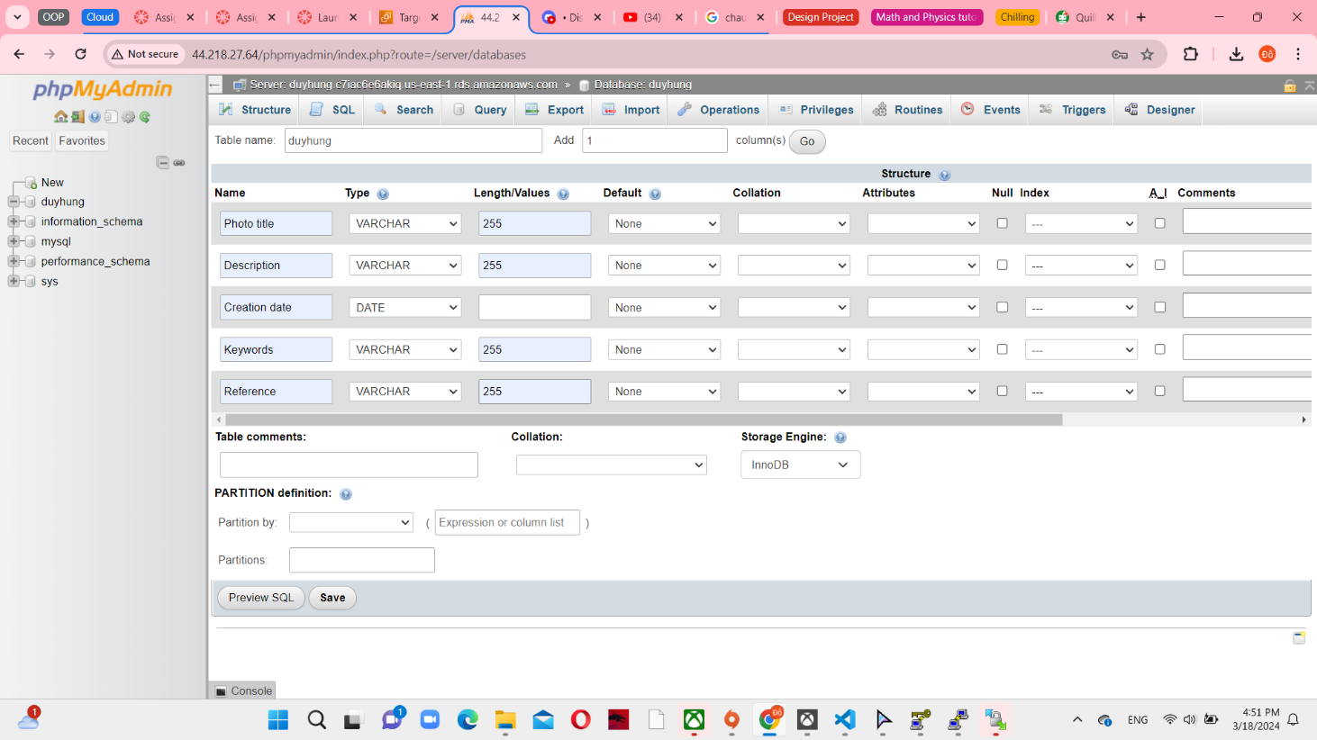

*Figure 32 Create database in phpmyadmin*

**Task 8: Create Lambda**

A Lambda function named “CreateThumbnail” and use python 3.11 as a runtime environment. Use LabRole as an existing role

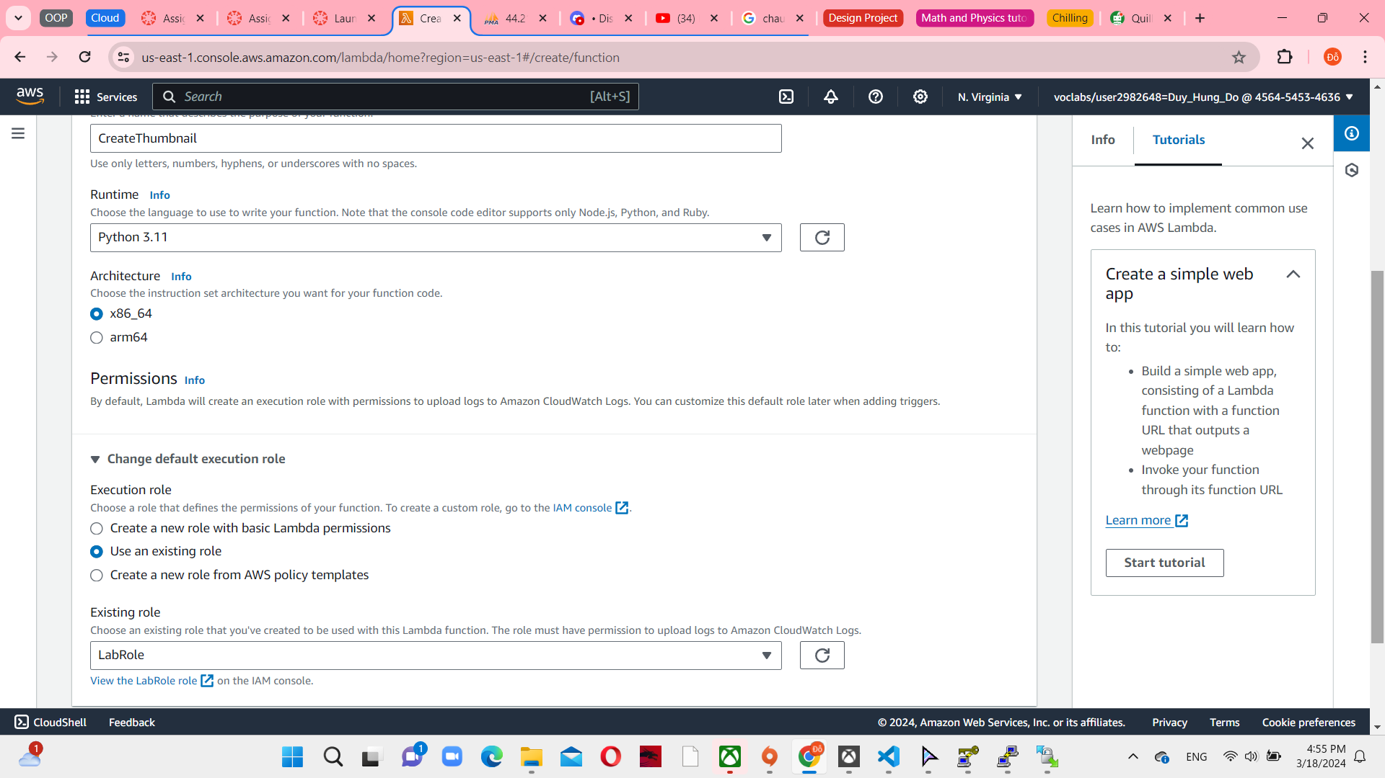

*Figure 33 Lambda function console*

After creating lambda function, upload a zip file as a python code in code sections. Both the necessary library and the entire source code for resizing images and handling downloads and uploads via the S3 bucket are provided in this package.

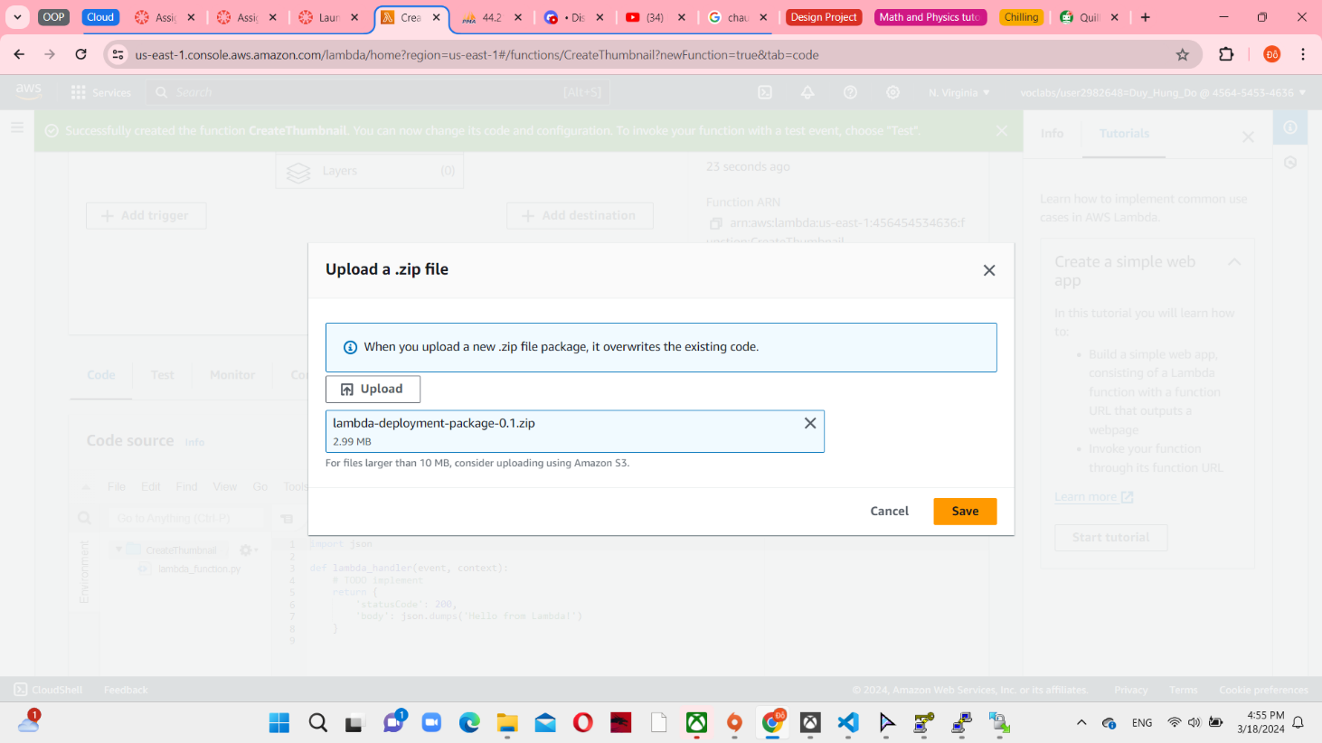

*Figure 34 Upload a zip file for CreateThumbnail*

To upload image in elb dns website, you have to add S3 trigger. Choose all object create events included put, post, copy, multipart upload completed.

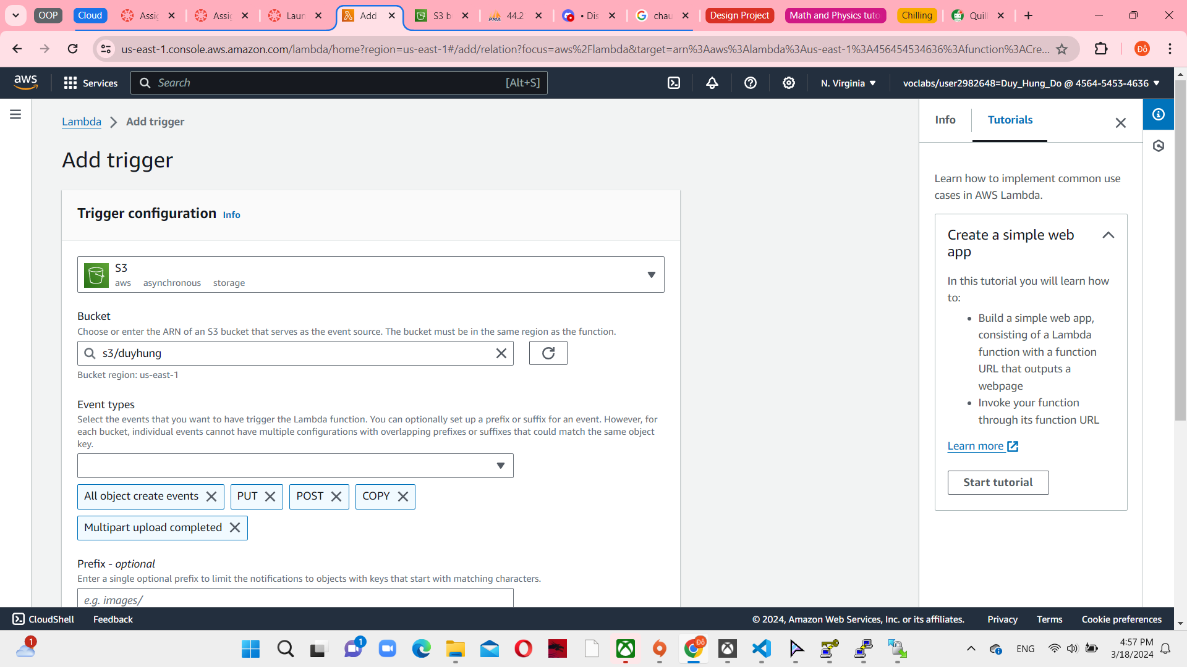

*Figure 35 Add trigger to CreateThumbnail*

**Task 9: Create Network ACLs**

In the final step, create network ACL to test the phpMyAdmin activity. Set with DHungVPC

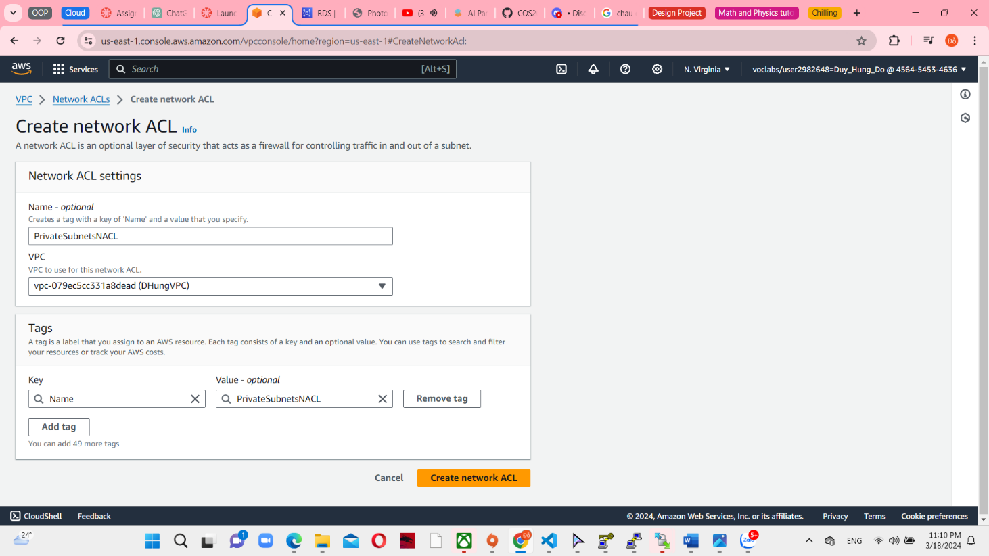

*Figure 36 Create network ACL console*

After that, edit subnet association as added 2 privates subnet and deny all from/to dev server instance

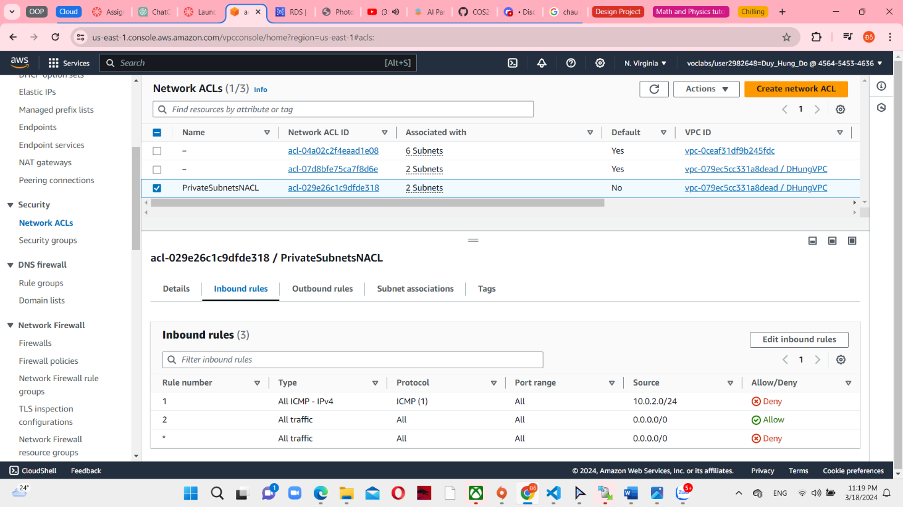

*Figure 37 PrivateSubnetsNACL associations*

**Task 10: Testing**

Firstly, test the ipv4 public and private in dev server. I try to ping it and it ping successfully.

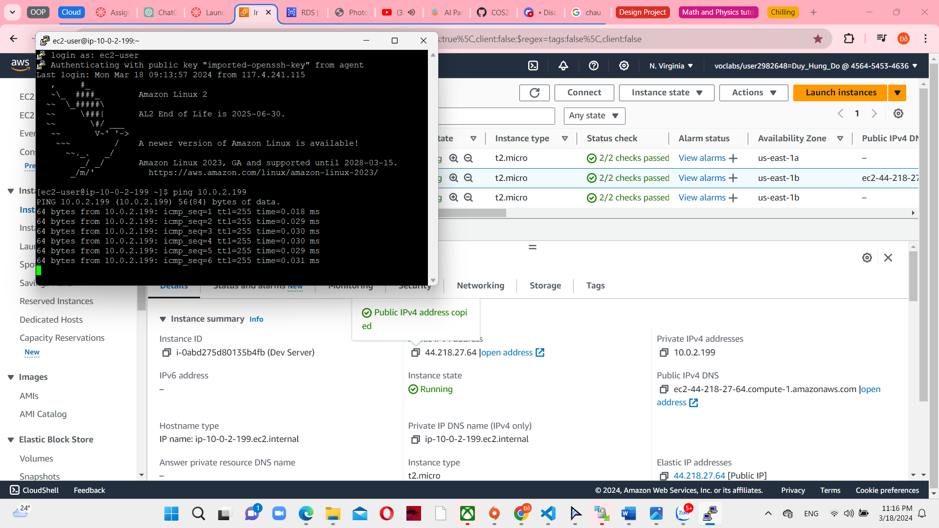

*Figure 38 Ping 44.218.27.64 successfully*

And then, I’ll try open against the phpMyAdmin after I created PrivateSubnetsNACL and it still running correctly.

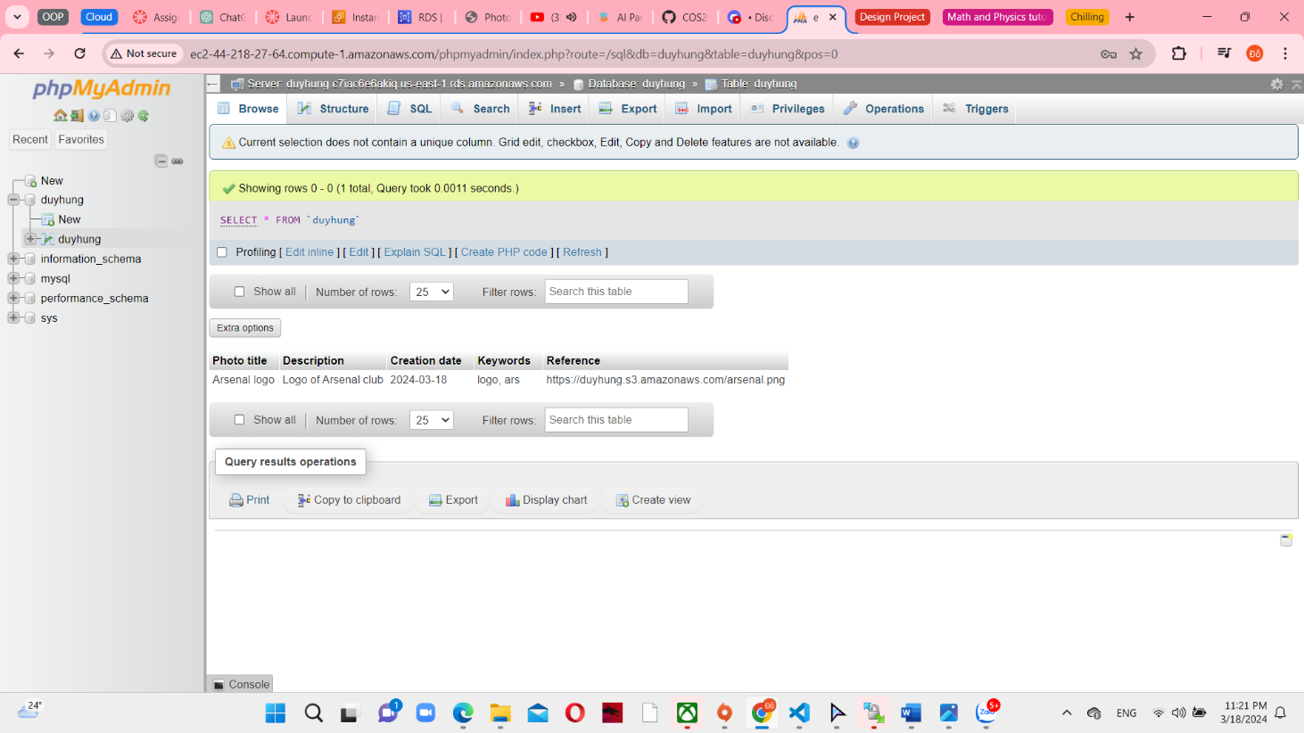

*Figure 39 phpmyadmin run correctly*

To access the photoalbum website, use the elb dns to open that I have attached the link in the first page of this report. By using this page you can upload more photo without using phpMyAdmin.

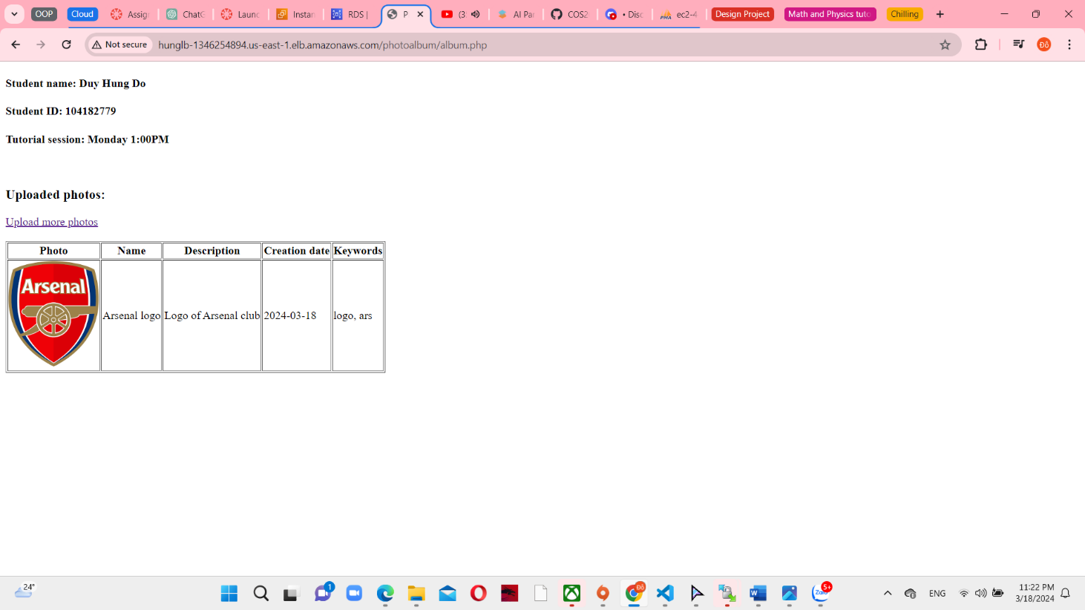

*Figure 40 ELB DNS website checked*

This file is allow you to upload other photo. Here I have insert Chelsea.png

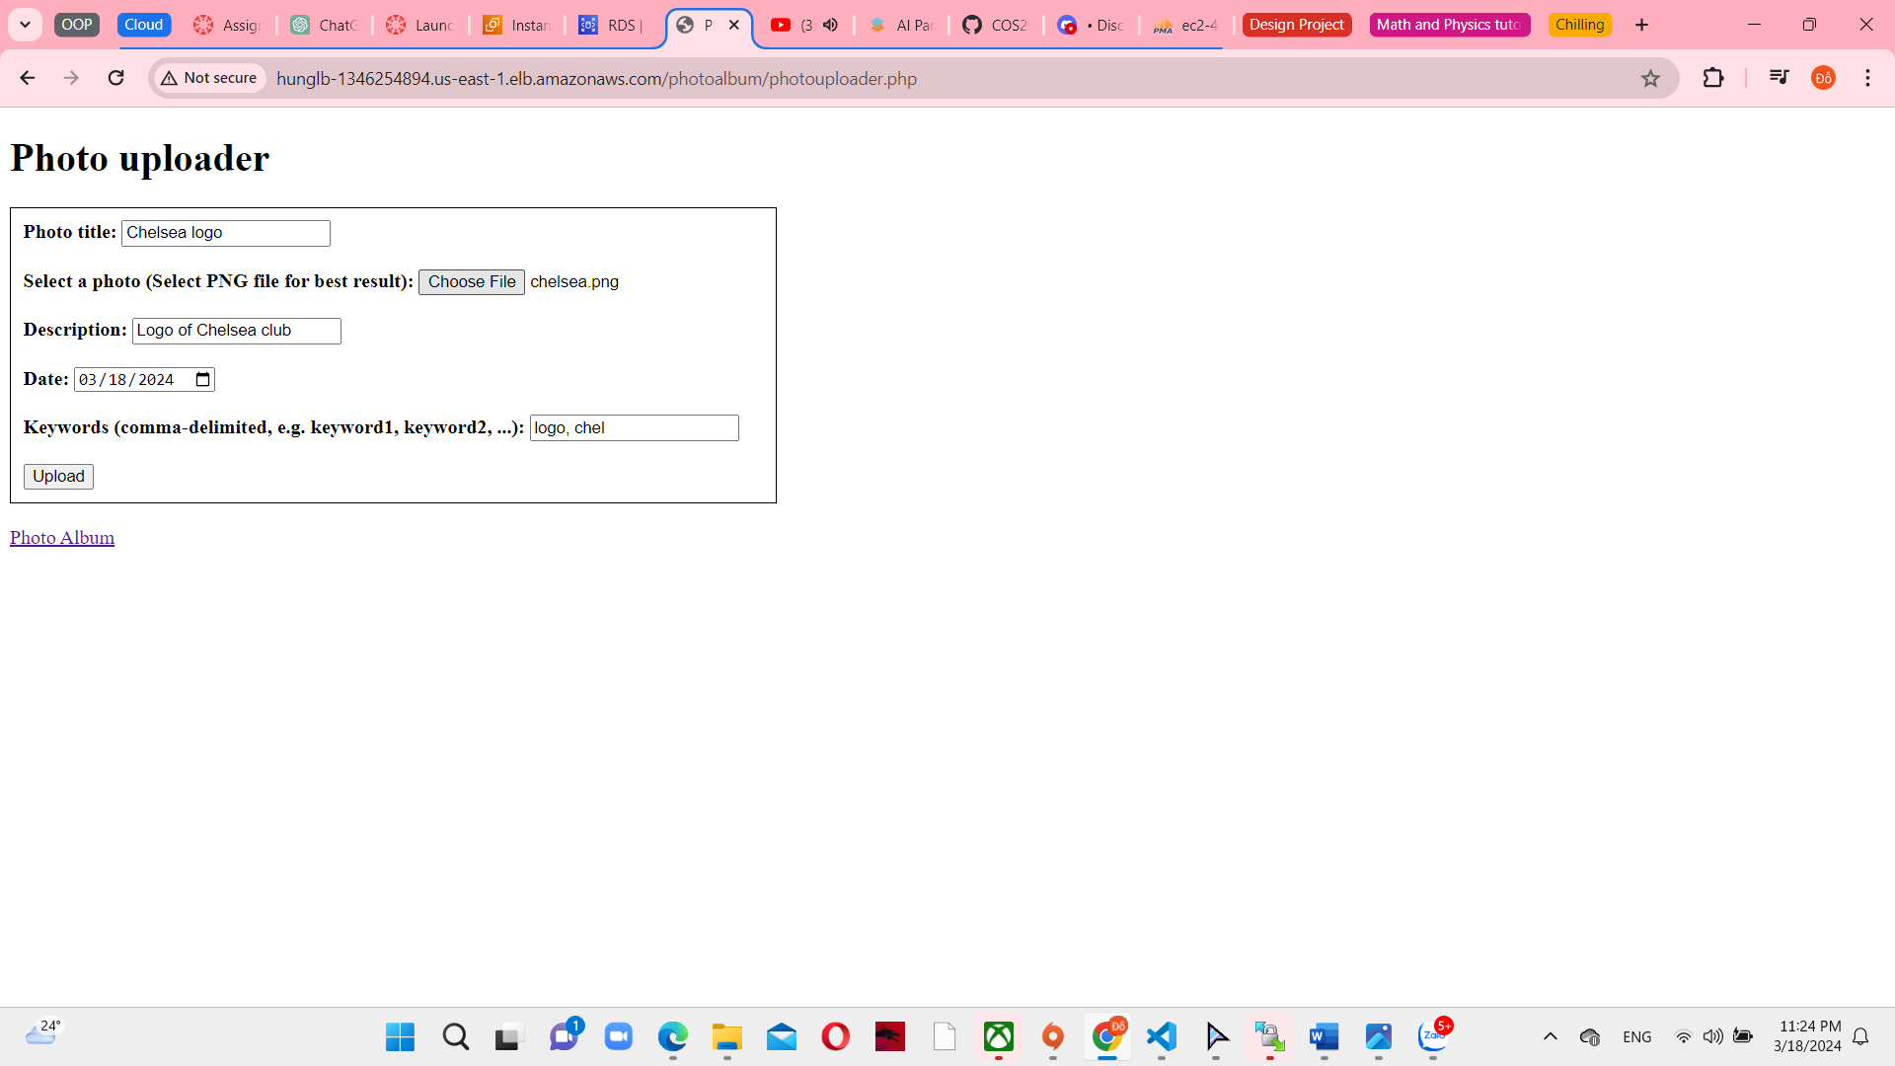

*Figure 41 Photo Uploader*

Here is my new web server when I refresh.

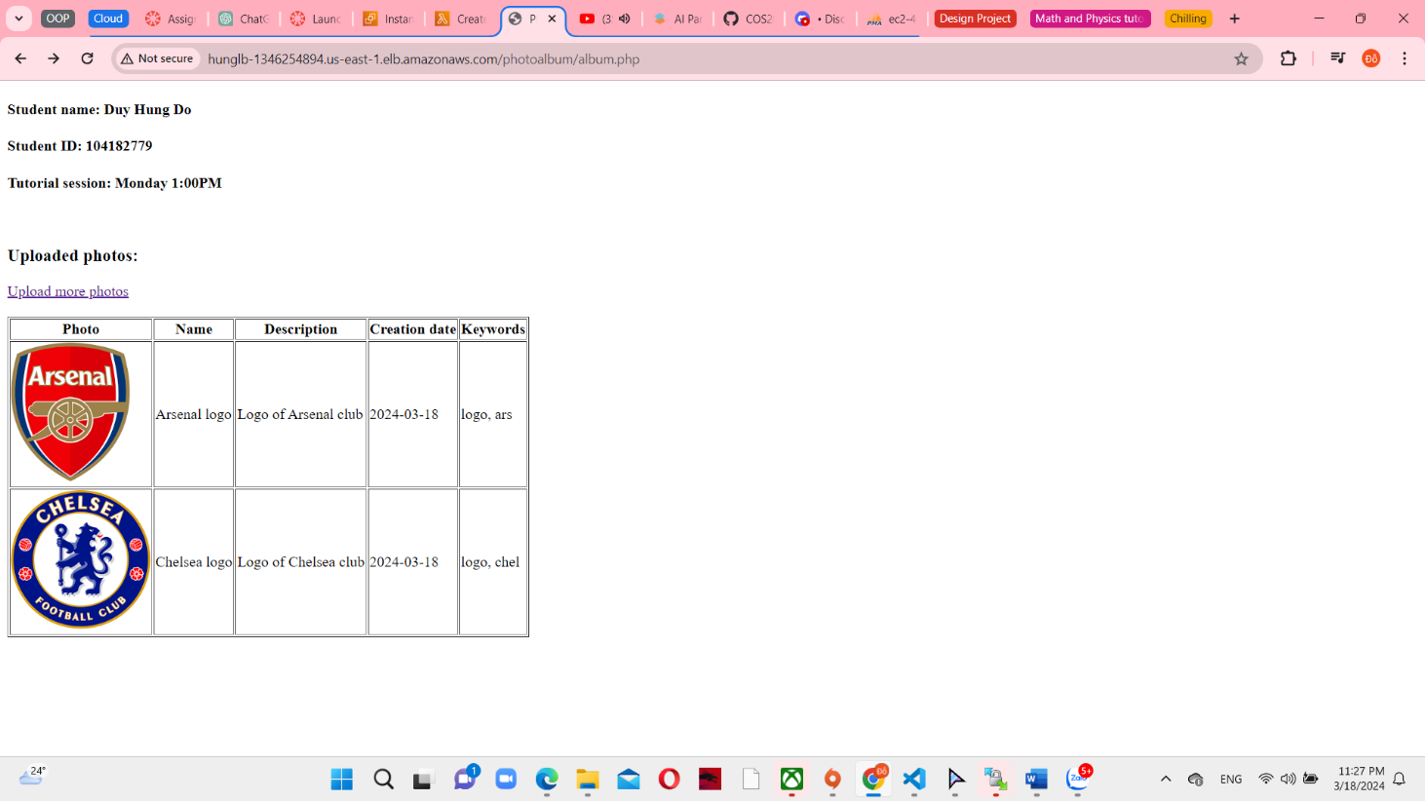

*Figure 41 Photo Upload correctly.*